**[Module #1: Getting Started with Data Objects 10Feb2025](https://utmssa.z19.web.core.windows.net/module3.html)**

* Create Data Objects
  + Declare Class and Data Objects:
    - <classname> <object name> = new <classname()>;
* Declare Data Objects as immutable
  + String immutably: (Data) Cannot change once it’s created
    - Get / Set: Get—Retrieve the data, Set—Write the data
    - Original string will not be overwritten
    - 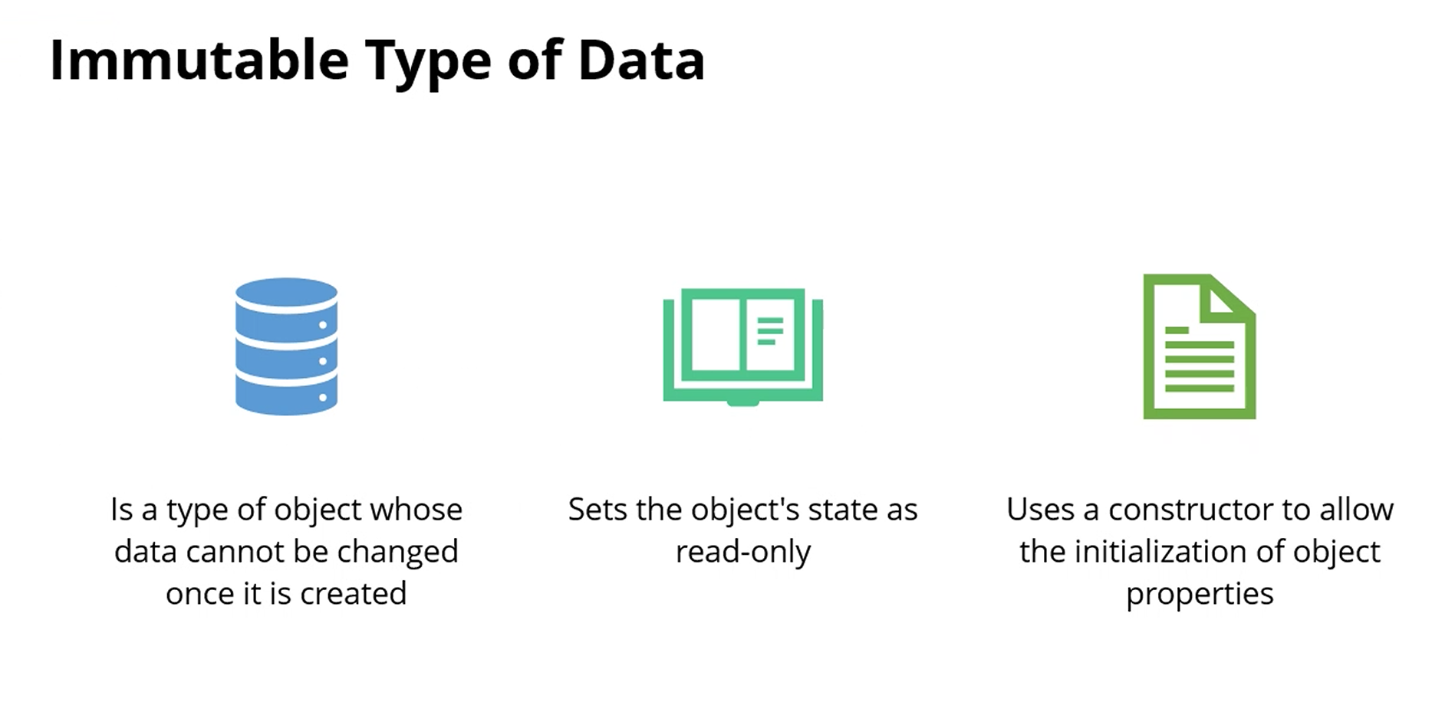
* Data Objects
* 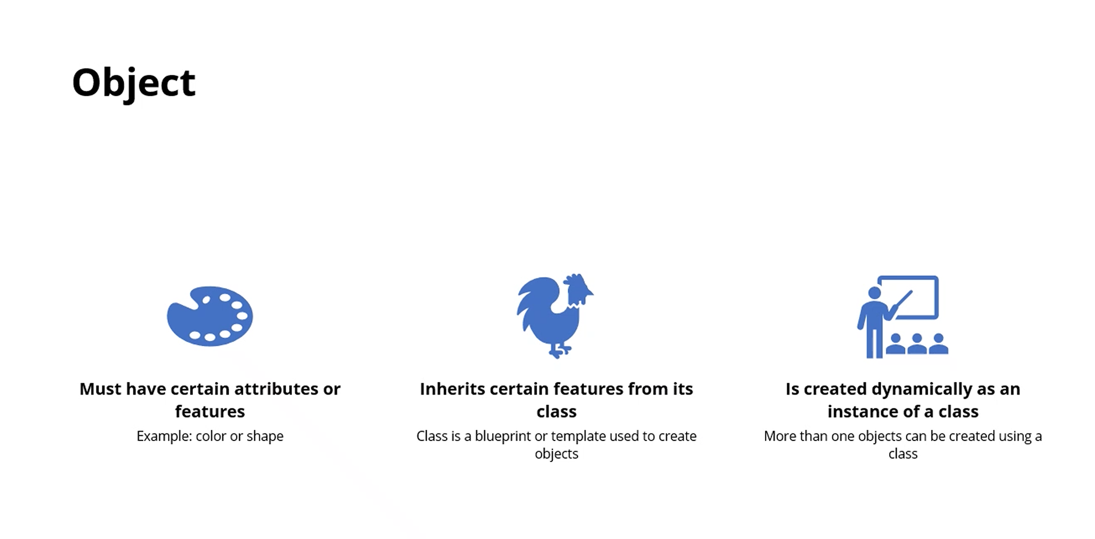
  + Characteristics: Color, shape
  + Create a class: class <classname>
* Creation of Parameterized Constructors
  + 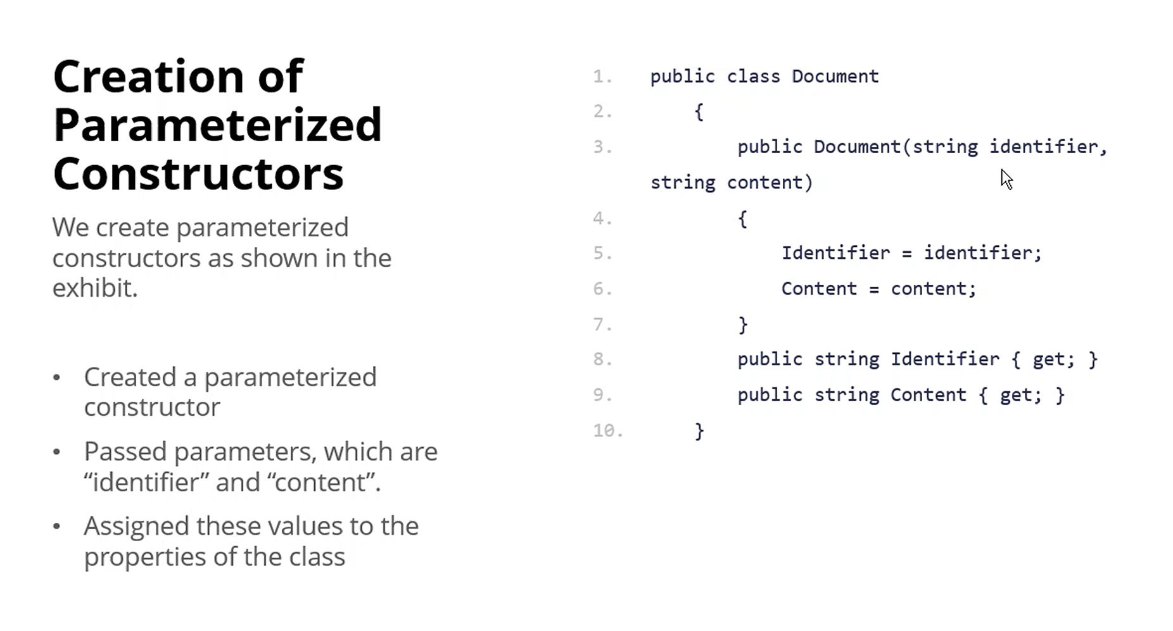
  + Get blocks = READ ONLY
* Imperative Programming
  + Telling the machine, “How to do it”
  + Employs statements to modify the state of the program
  + Divides the statements into methods to make them easier to comprehend
  + Requires implicitly coded ….
* 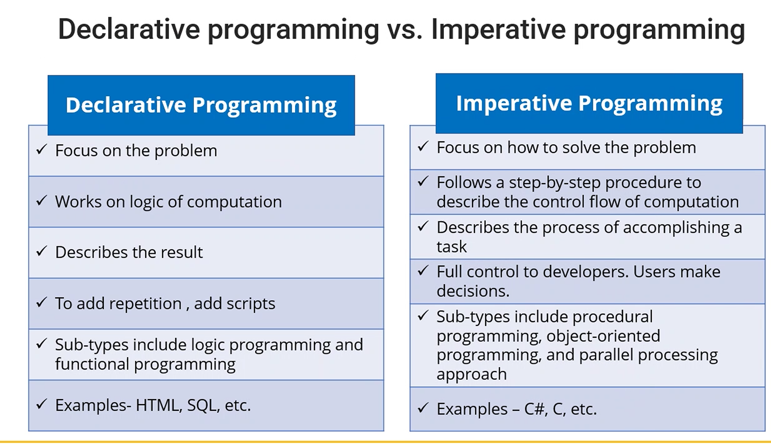
* C# Methods
  + PascalCase used
  + 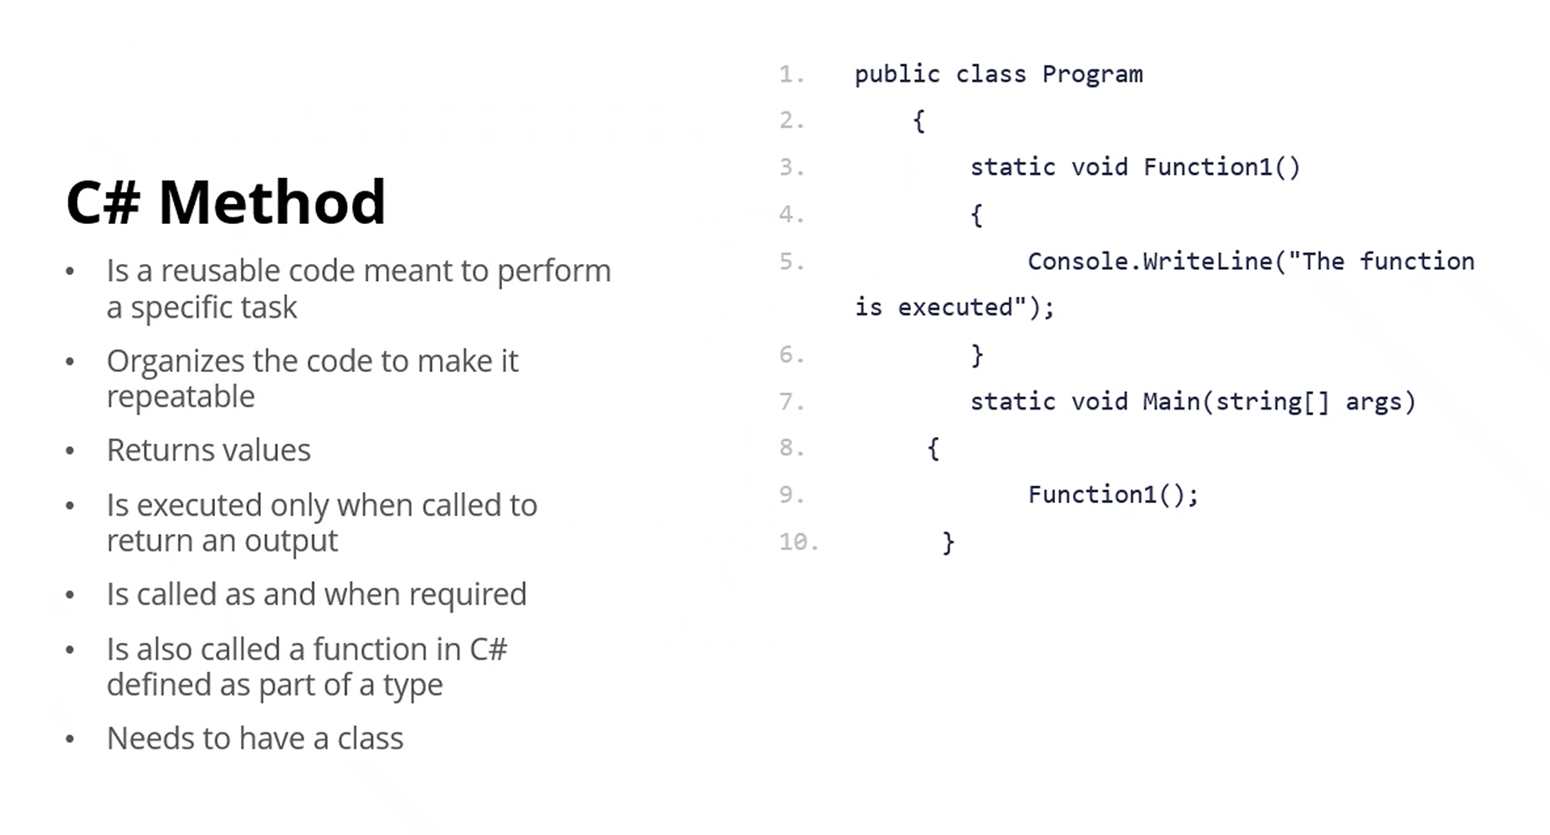
  + 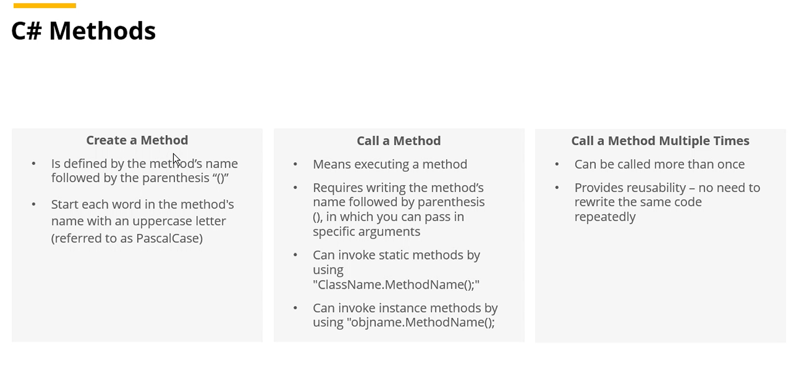
  + Calling—^^
  + 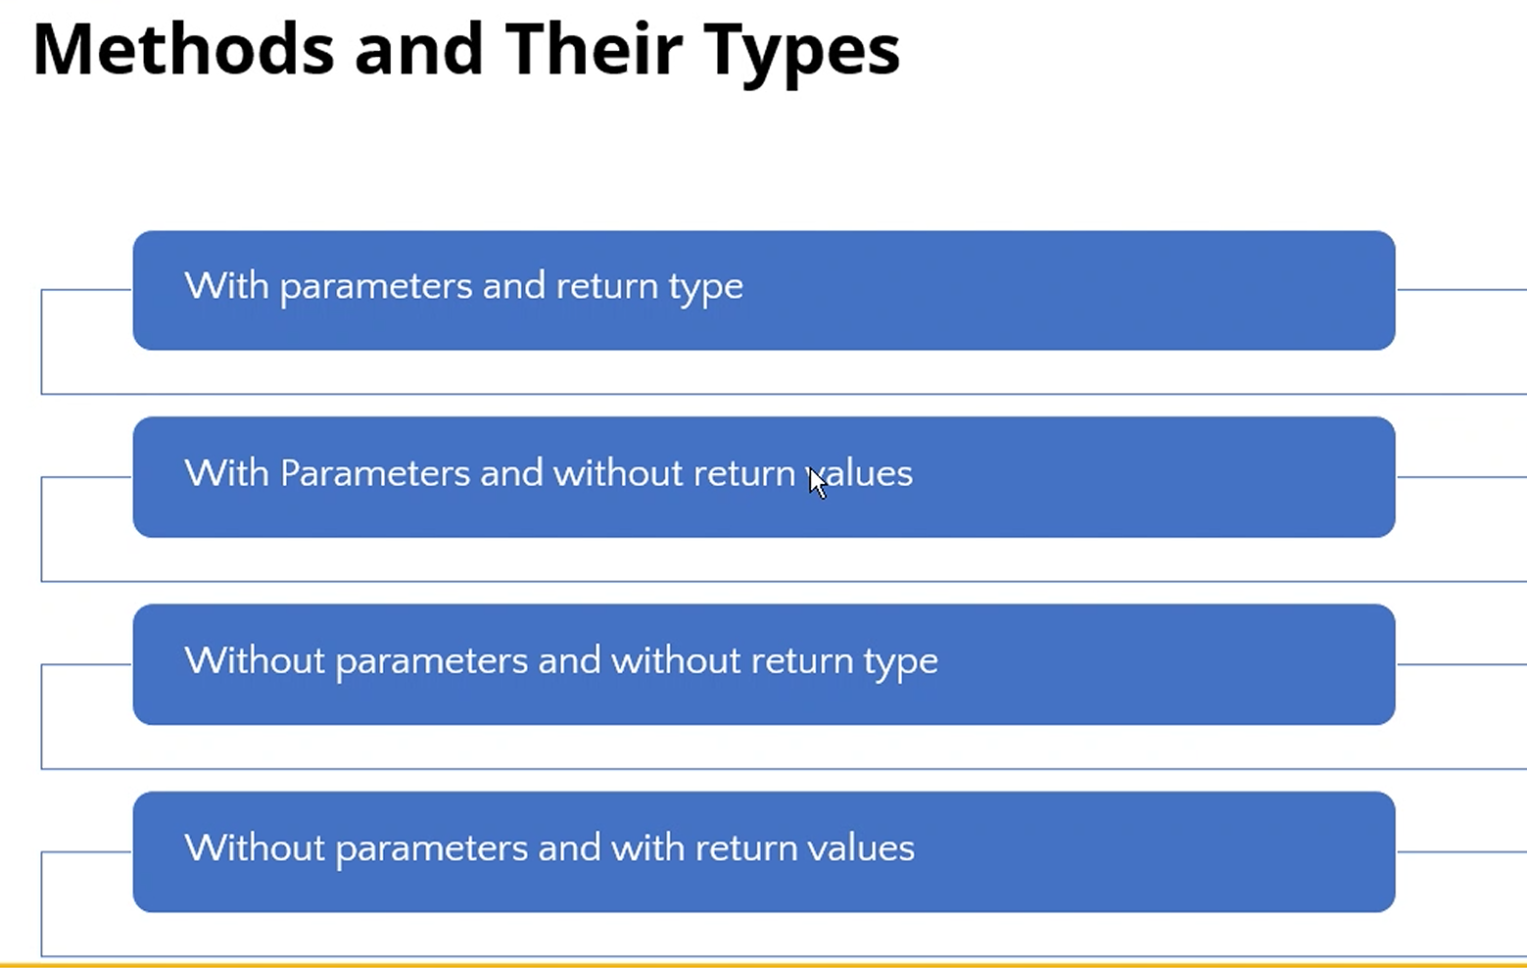
* Loops
  + 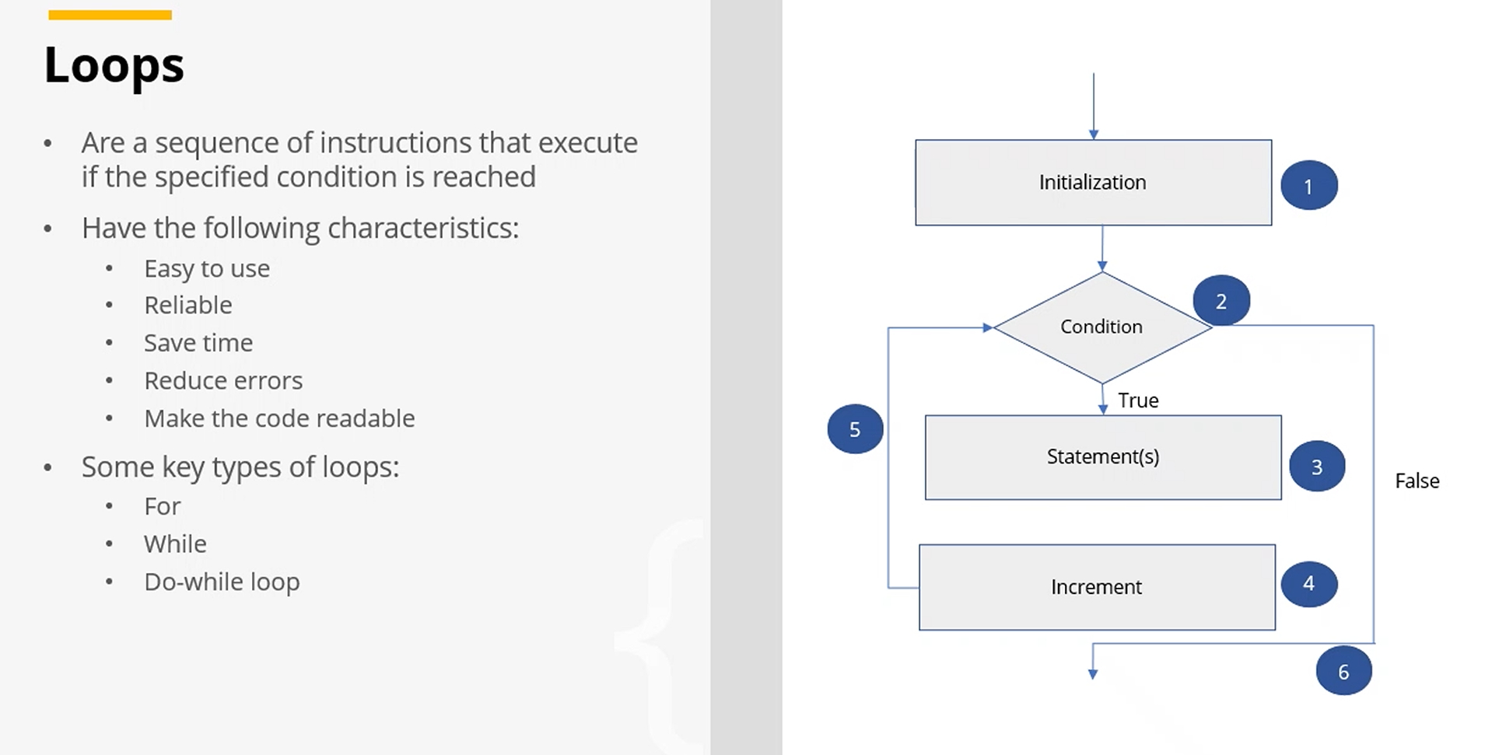
  + 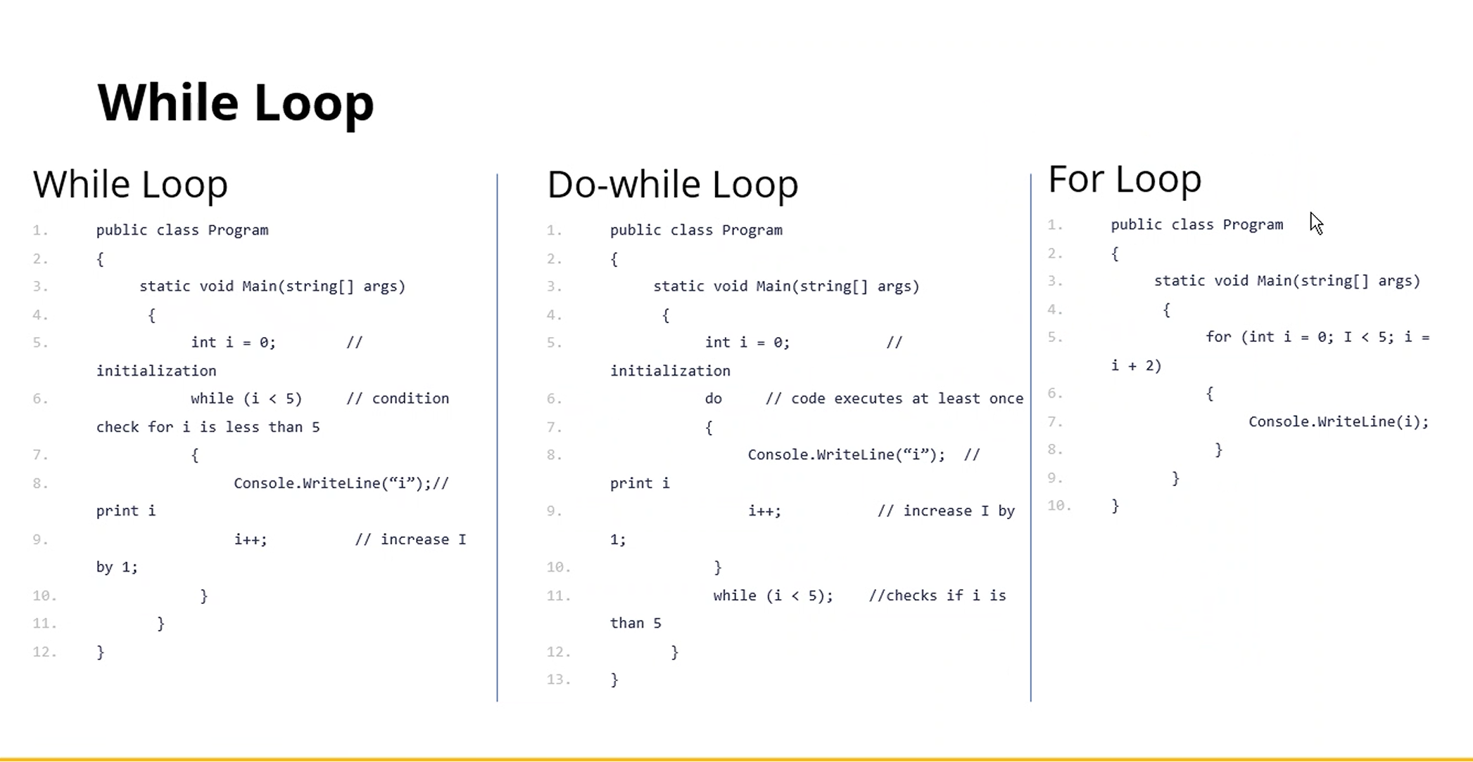
  + 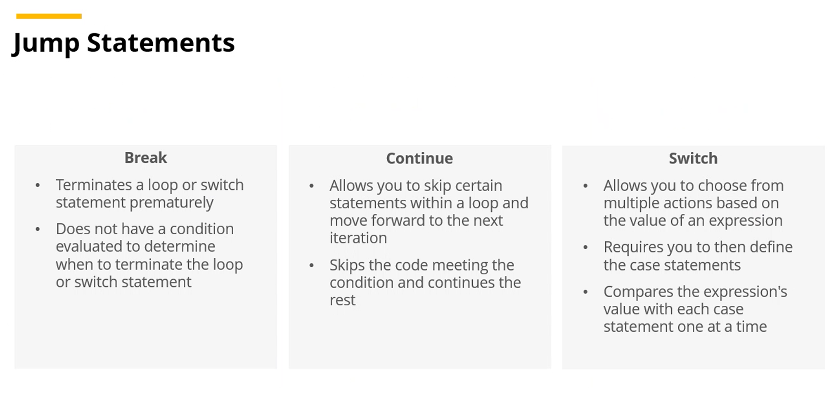
* [Foundations of Data Structures](https://utmssa.z19.web.core.windows.net/module2.html)
  + *Data*—Any information which is relevant to the application/program
    - Stored in…documents, photos, videos,
  + *Data Structure—*Way/method of storing information to efficiently access it
    - Linear list, Queues, Graph, Arrays, Lists, Stacks, Linked Lists, Trees, Hash Tables
      * Linkedlist, doubly linked list (like a song playlist)—more linear list stuff?
  + *Algorithm—*step-by-step procedure for solving problems effectively; for effective use of algos, you need appropriate data structures; the code part of your business logic you are supposed to do in the application
  + *Program—*S
  + ADT—Abstract Data Type—Idea / concept that tells us the behavior but does not discuss the details of implementation
    - Stack: push, pop, peek (example)
    - When writing a Stack (just an example) in C#: it becomes a concrete data structure with implementation
* Need of Arrays

**Module #2: Foundations of Data Structures 11 Feb 2025**

* Need of Arrays
  + 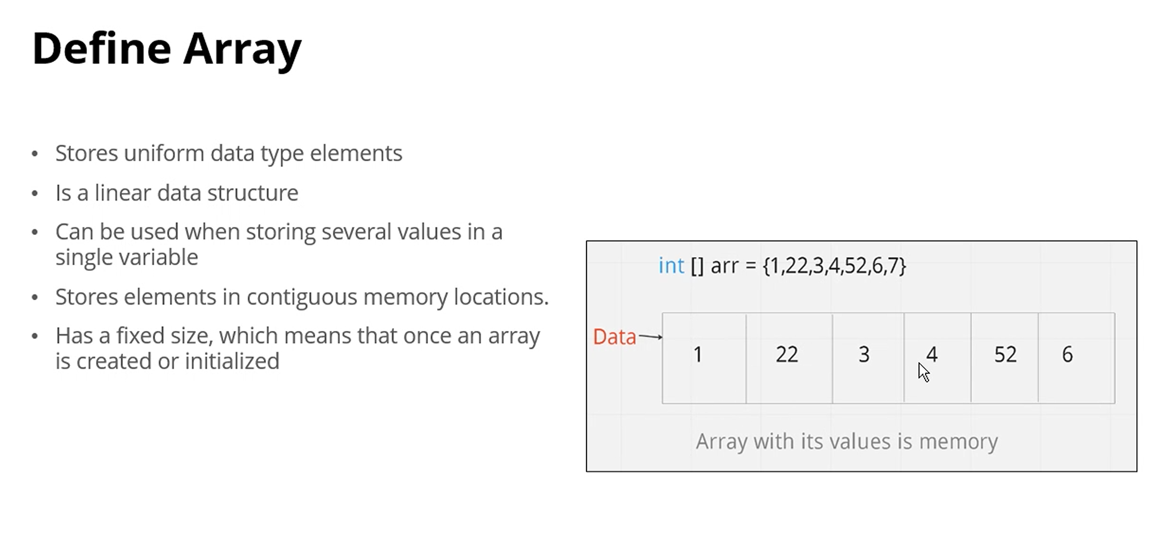
  + Arrays are reference data type (heap)
  + 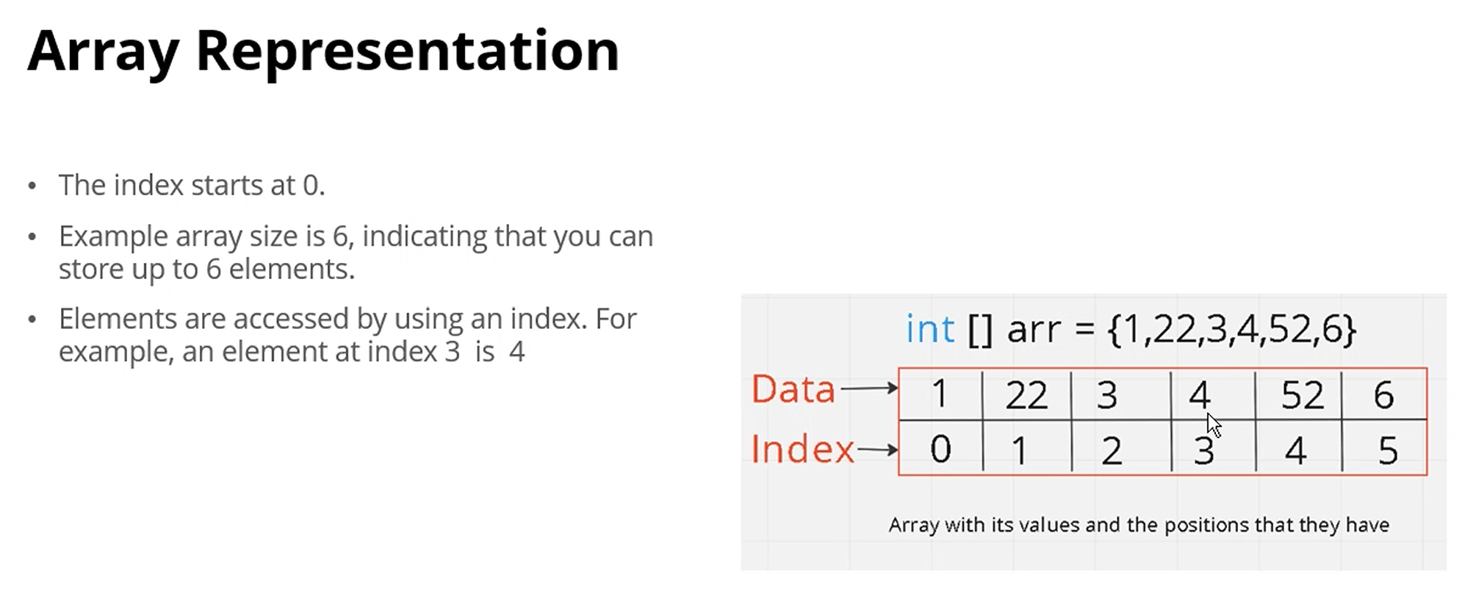
  + Key operations on an array:
    - Traversal
    - Insertion
      * Can only insert at end(?)
      * Never insert or delete elements unless it’s at the end, basically
      * Also have to have empty spaces at the end or you’ll get an Index out of Range error
    - Deletion
      * Cannot delete the memory spot, have to replace it with a different value (like -1) to represent its deletion
      * Memory cannot be reclaimed
    - Searching
      * Linear search
    - Update
      * Replace any element with another value
    - Copying
      * Copy entire array from one array to another
    - Reversing
      * Get reverse order
    - Sorting
      * Sort by…(?)
    - Clear
      * Array is still there, but elements in the array are replaced with 0 if it is an int array
  + 2D array—fill in using nested for loops(?)
    - 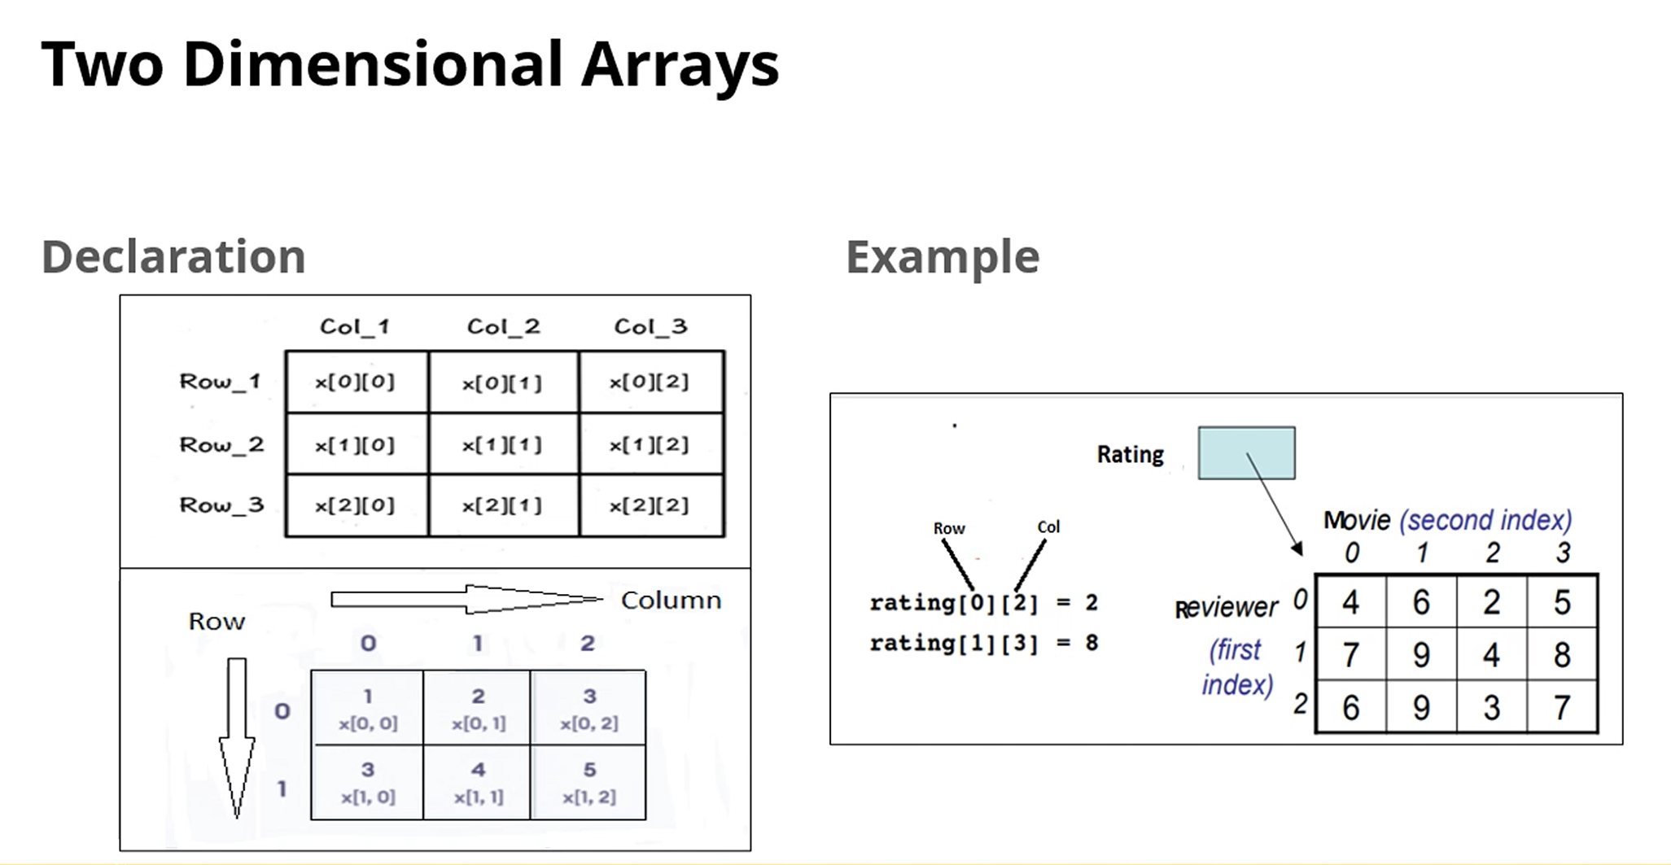
  + Jagged Arrays
    - 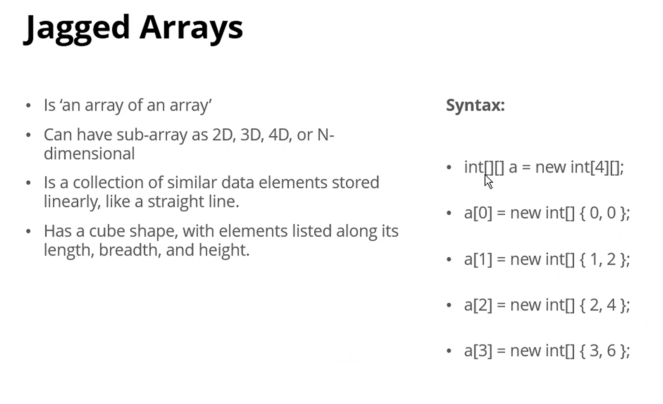
    - Int[ , ] a = new int [4, ] **???
  + Applications of Arrays—Useful in:
    - Storing and accessing Data
    - Sorting
    - Searching
    - Matrices
    - Stacks and Queues
    - Graphs
  + Advantages
    - 1D Array elements can easily be accessed by using the index #, so if you know the index number, the retrieval time of the array is O (1)
    - Searching can be applied to arrays very easily
    - 2-D arrays are used to represent matrices
    - Arrays allocate memory in contiguous memory locations for all its elements
  + Disadvantages
    - You need to know the # of elements at the time of the creation of the array
    - An array stores the elements in a contiguous memory location. Insertion or deletion of elements is a difficult process. The shifting of elements is costly
    - Allocating more memory than the requirement wastes memory space
* [Recursion](https://learn.educate360.com/learn/course/mssa-pcad16-1/data-structures-and-algorithms-week-5/week-5?client=mssa&page=2)—A programming method using which a function calls itself until it performs a repetitive task. A function can call itself repeatedly to accomplish the same task. A STACK stores the local variables and parameters in internal memory
  + A technique to solve a problem/repetitive task by using function call to itself. Each function call will solve part of the problem
    - 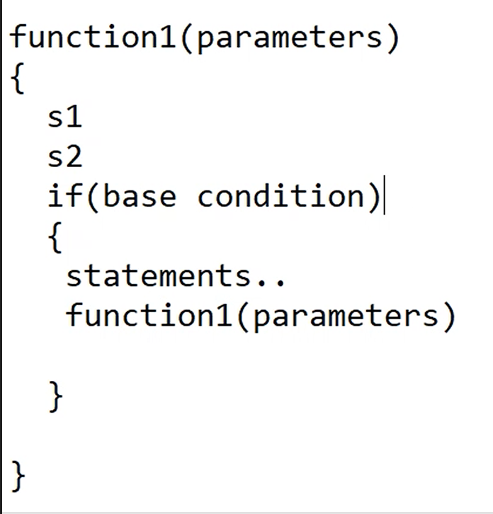
    - 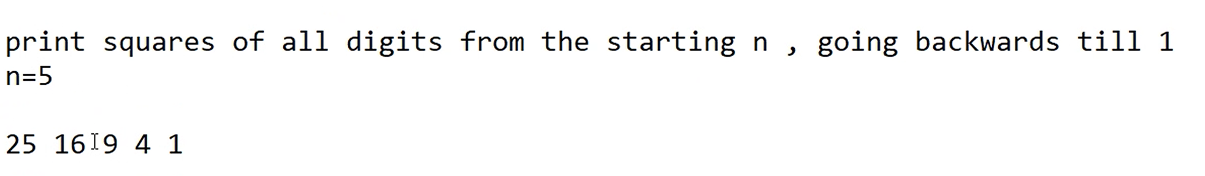
    - Pseudo-code:
      * 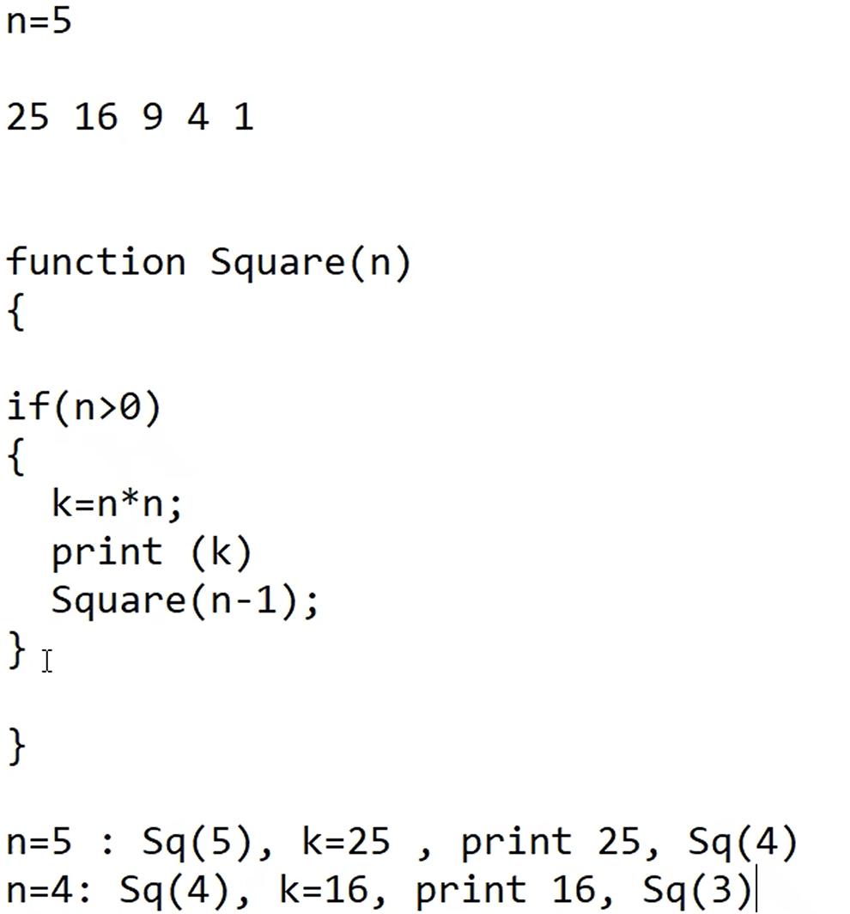
      * 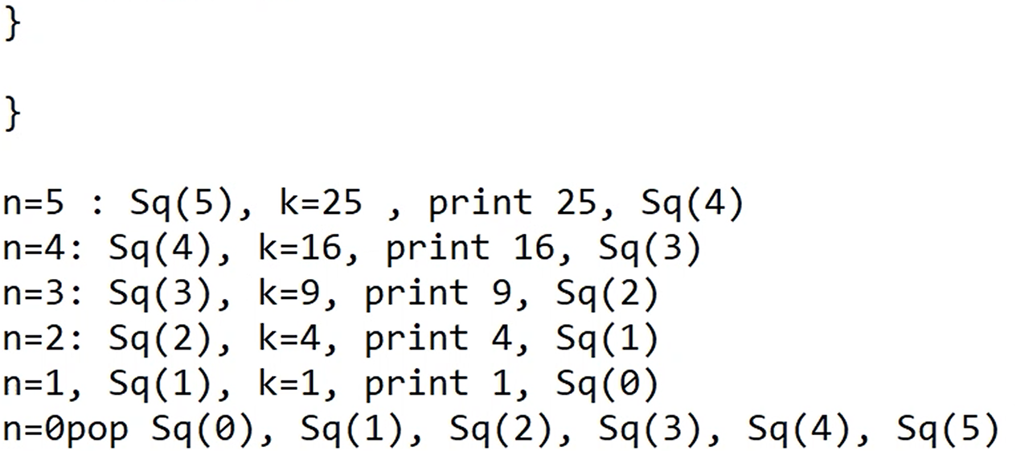
      * Popping out: This empties the memory stack
      * 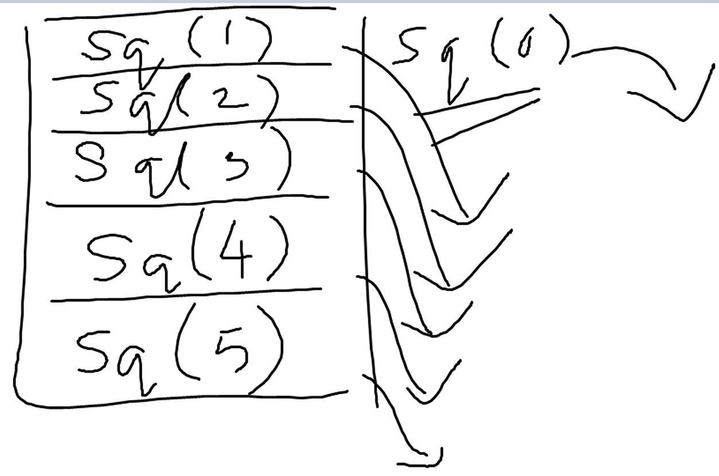
      * Factorials visualized
      * 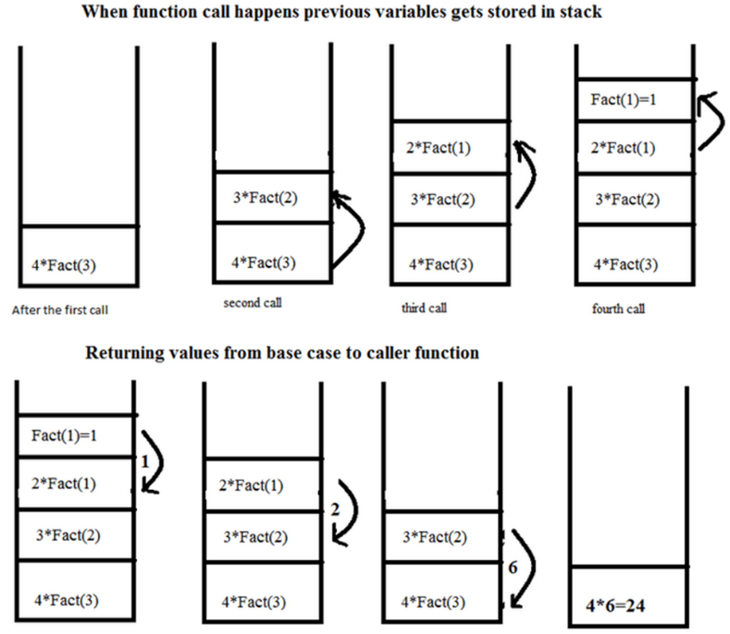
  + Need for recursion:
    - Simplifies complex problems
    - Callback functions
    - Dynamic programming—can be used in dynamic programming to optimize the performance of algorithms by *reusing previously calculated results*
      * *Dynamic programming*—a method that breaks down a problem into smaller parts. Solves each smaller part and stores the results in a table
  + Types of Recursion
    - Direct
    - Indirect
* Linked Lists, Stacks, and Queues
  + Stack
    - Linear data structure
    - Stores data in a sequence
    - Is an Abstract Data Type (ADT), a type (or class) that encapsulates the behavior in the form of attributes and operations
    - Is FILO (First In, Last Out) or LIFO (Last In, First Out)
    - Push()—function adds or inserts new elements into the stack
    - Pop()—function deletes or removes an element from the stack
    - Peek()—Function is used to get the top element from the stack without deleting it—just to have a look at the top element
    - 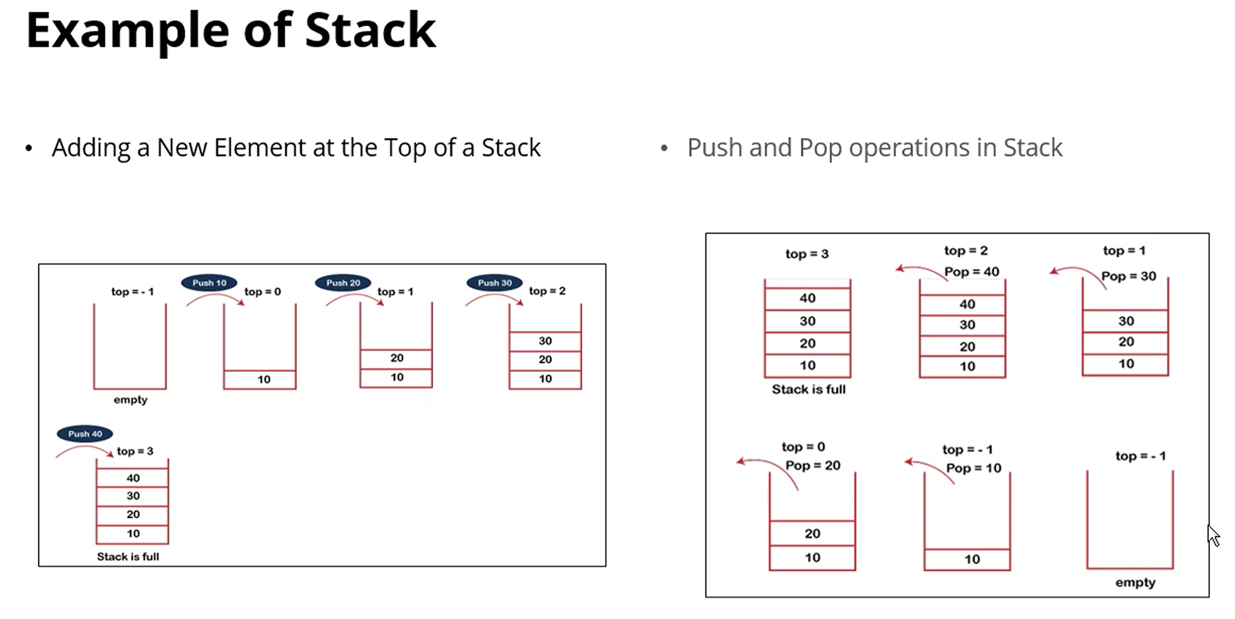
  + Linked List—A linear data structure collection of data elements randomly stored in memory. Each element is called a ***node***—that stores the actual value as data and a reference/address to the next node. Provide fast insertion/deletion of elements but have slower access times than arrays or lists
    - 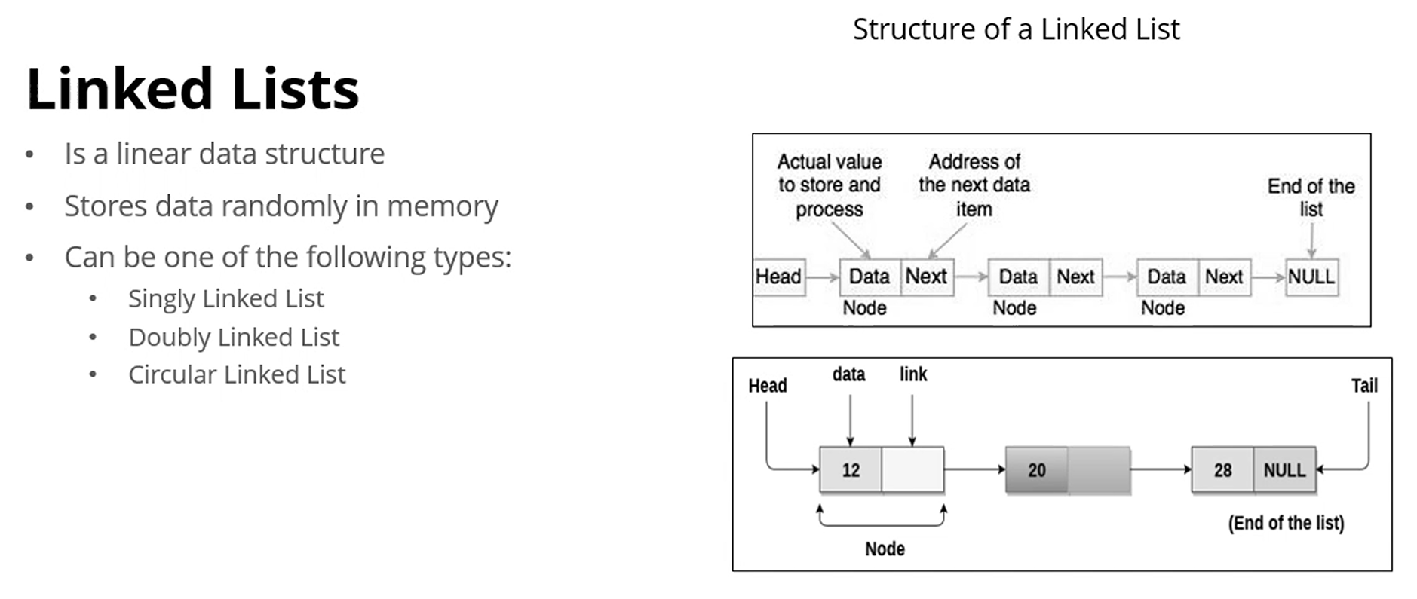
    - Singly linked list—can only go forward. Last node contains value and null (null as reference to next node since it’s the end)
      * 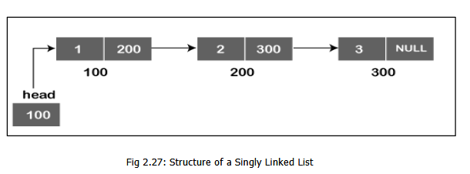
    - Doubly linked list—can go forward or backward.
      * 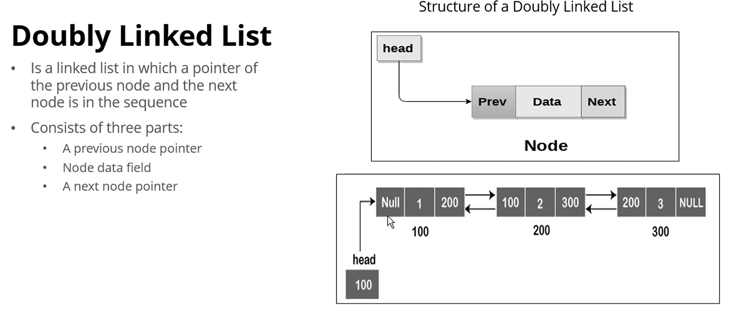
    - Circular linked list—
  + Queues
    - 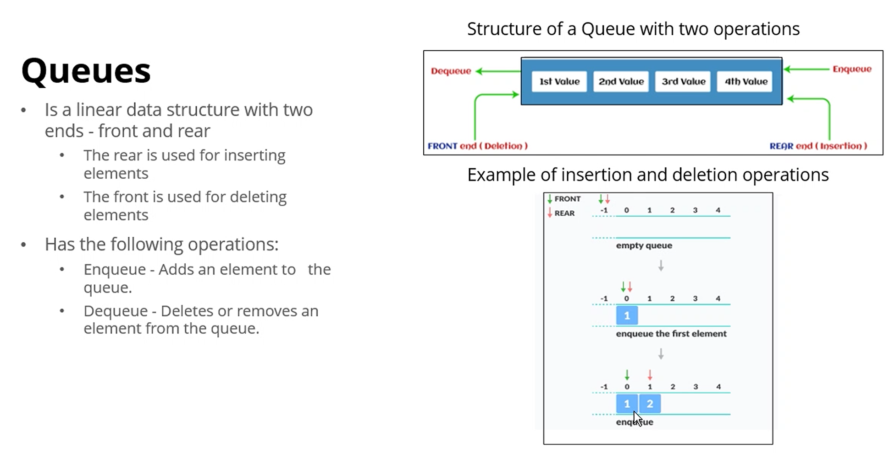
  + String and String Builder
    - 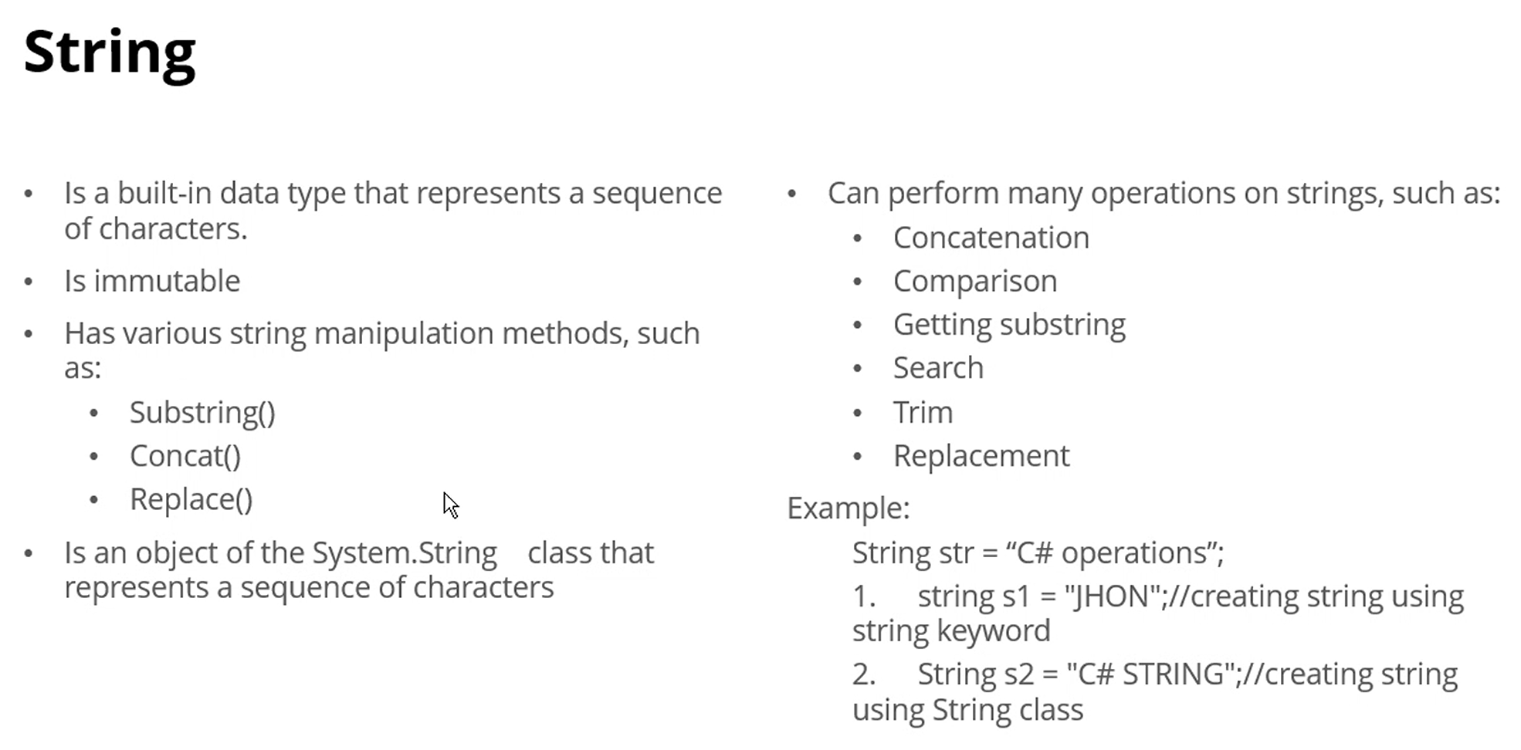
    - 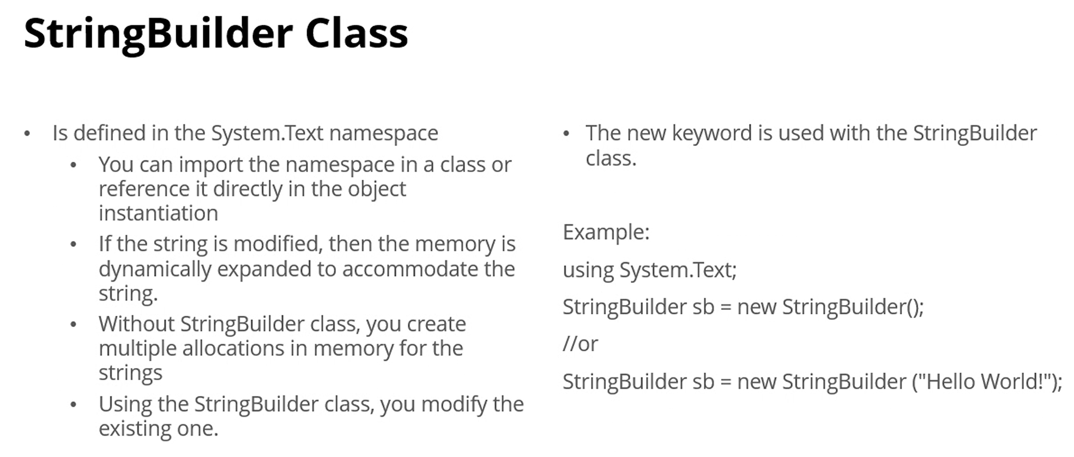

[**Module #3: Algorithms 12 Feb 2025**](https://learn.educate360.com/learn/course/mssa-pcad16-1/data-structures-and-algorithms-week-5/week-5?client=mssa&page=3)

* *Algorithms—*instructions or a set of rules designed to solve specific problems or perform certain tasks
  + 1. Plan, steps
  + 2. Set of instructions to achieve a certain result
  + 3. Execute in finite amount of time
  + 4. Correctly defined computation procedure which has a definite input and output
    - Algo will work for that type of input only (numbers/ints only, string only…)
  + 5. Even if quantity changes as input, algo should still work
  + 6. Write pseudo-code then we convert it into program
  + 7. Possible to measure the performance of algos
  + 8. Time taken, space required (like creating a new array just to store a new array or doing it in place)
* 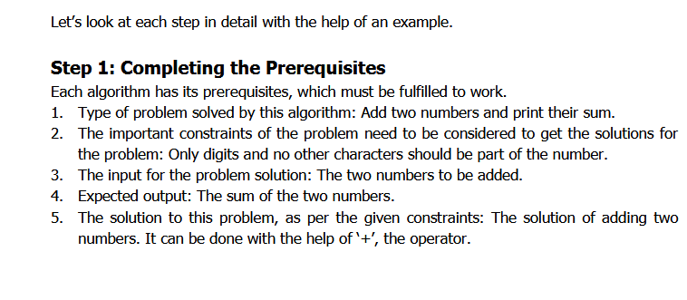
* 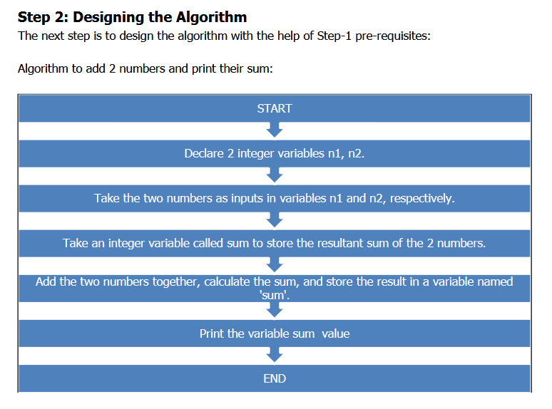
* 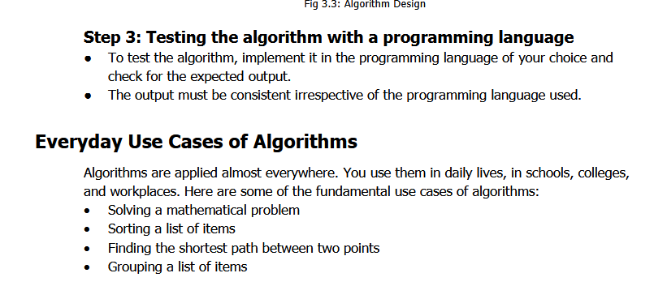
* *Characteristics and Properties of Algorithms*
  + 1. Clear and unambiguous—A single way to interpret an algorithm, should be completely clear about what it means. Each step is clearly defined. Each step must conclude something
  + 2. Well-defined input—Can take 0 or more inputs; its data type should be specified, and the input must be precise
  + 3. Well-defined output—Should match with expected output, can produce one or more outputs; output is dependent on the input
  + 4. Finiteness—Must have a finite number of steps, cannot run forever, cannot have an indefinite number of steps
  + 5. Feasible—Must be able to run within the given resources
  + 6. Language independent—Not dependent on any programming language, must be used consistently without modifications
* Advantages
  + 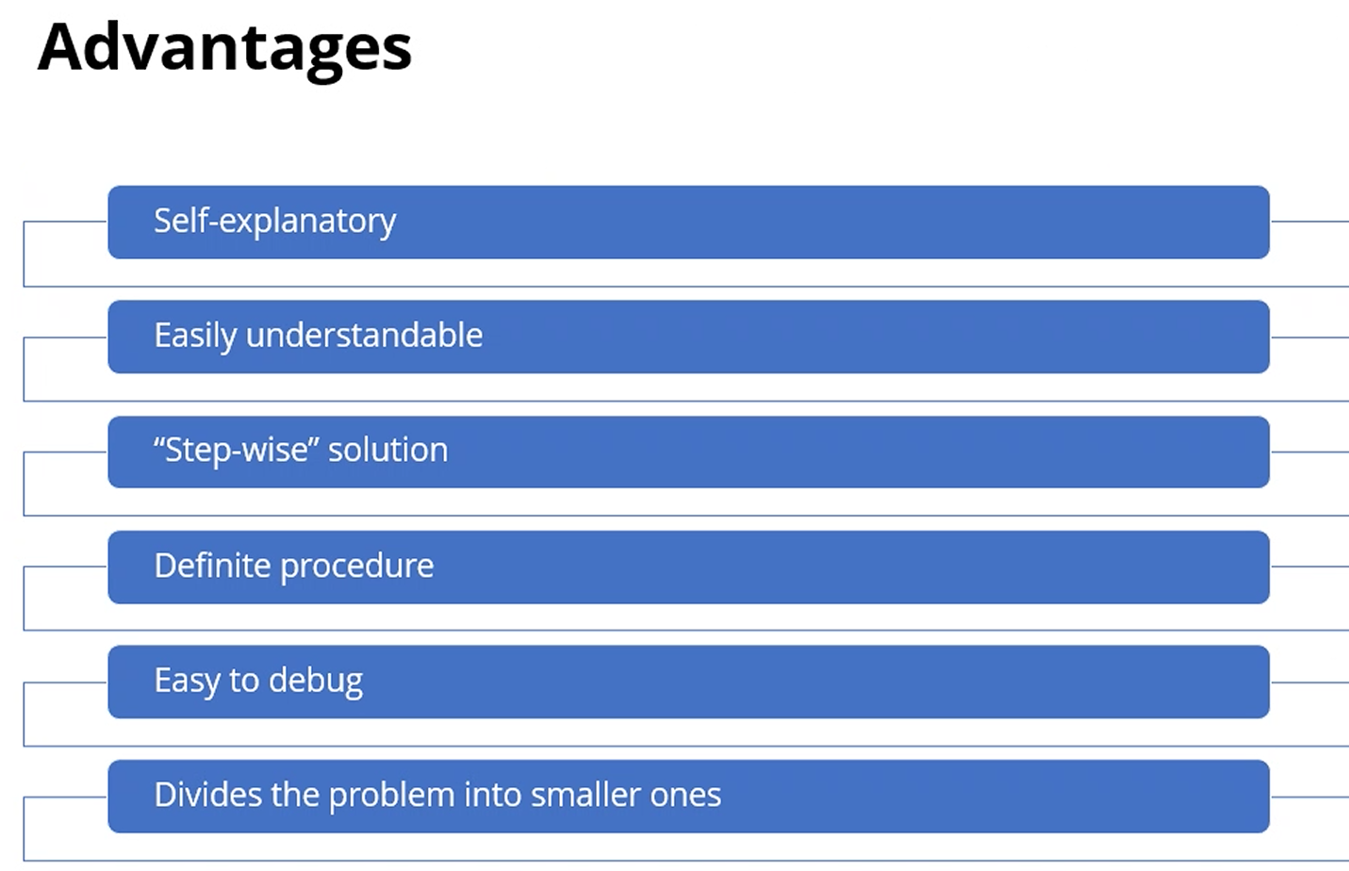
* Asymptotic Analysis
  + 1. How much time?
    - -Big O notation—O(n)
  + 2. How much time is needed if my input increases?
  + 3. How much space?
  + Analysis is needed to measure the goodness of algorithm
    - 1. Experimental analysis
      * Measure the run time of the code, literally, by giving different number of input
      * Timer
      * Hardware H/W dependent, Software S/W (OS) dependent
    - 2. Theoretical (asymptotic (?)) Analysis (Based on math)
      * Based on algorithm/description of steps
      * Independent of H/W and S/W
  + Primitive operations which take constant execution time—even though input varies, time required is constant (10, 100, 1000 inputs):
    - 1. Declaration statement:
      * int i;
      * create of object of a class classname yourname = new classname()
      * create a variable of a string
    - 2. Assignment:
      * i = 3;
    - 3. Arithmetic:
      * i = i + 1 (i++)
    - 4. Comparison:
      * i < 10
    - 5. Accessing element:
      * Arr[i] – array of i
    - 6. Function call:
      * add(4, 5)
    - 7. Return from functions
      * Return a value, return a statement
  + Example 1:
    - 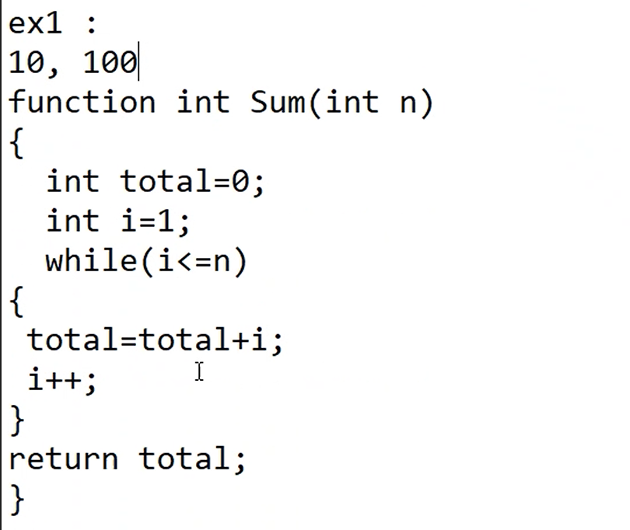
    - Go through line-by-line and check to see if they take constant execution time
      * Declaration = 2
      * Assignments = 2
        + Total = total + i is not because it’s part of the arithmetic
      * Comparisons = n+1—because it will compare i to n until it is = n
      * Arithmetic = n + n—one is for total, one is for i++
      * Return = 1
      * Total: 2 + 2 + n + 1 + n + n + 1 🡪 ***6 + 3n*** 🡪 linear (has single, not-nested loop)
        + n represents how many times the loop will process

This makes 6 pretty negligible (n could be 100, or 1000…)

* + - Linear is better
  + Example 2:
    - 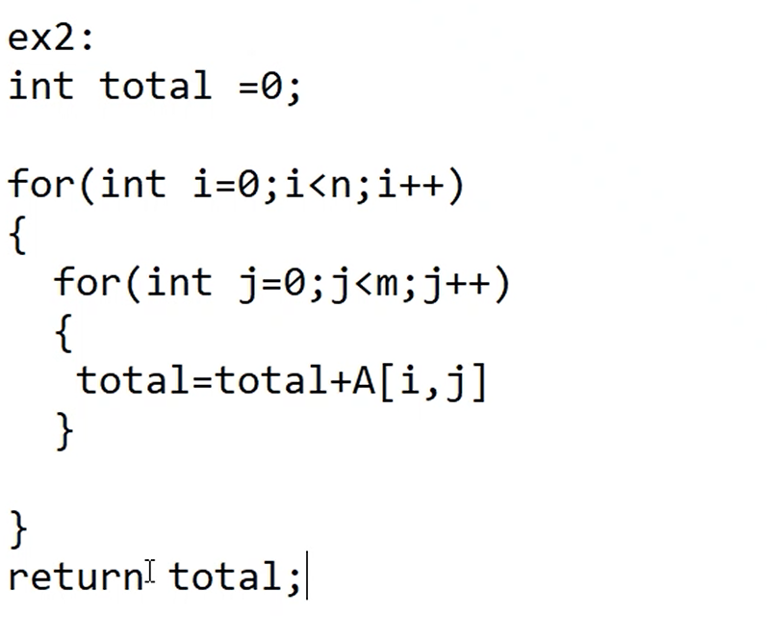
    - Declarations: 1 + 1 + n (int j is executed n times, not m)
    - Assignments: 1 + 1 + n (int j for n)
    - Comparisons: (n + 1) + (m + 1)*n 🡪 n + 1 + n*m + n 🡪 1 + 2n + nm 🡪 1 + 2n + n^2 (n^2 because we’re assuming n and m are similar values (m=n))
    - Accessing array A[i, j]: n*m 🡪 n^2
    - Arithmetic:
      * Increment: i++ 🡪 n+1, j++ 🡪 (m+1)*n 🡪 n+1 + (m+1)*n 🡪 1 + 2n + n^2
      * Basic: n*m 🡪 n^2
    - Return: 1 (negligible)
    - Total: 1 + 1 + n + 1 + 1 + n + 1 + 2n + n^2 + n^2 + 1 + 2n + n^2 + n^2 🡪 6 + 6n + 4n^2 🡪 omit 6 (negligible) ***6n + 4n^2***
      * Consider a number like n=6000
        + 6000 + 4*1000000

Complexity = n^2

Add another nested for loop, complexity = n^3

* + - Nested loops take a long time
  + 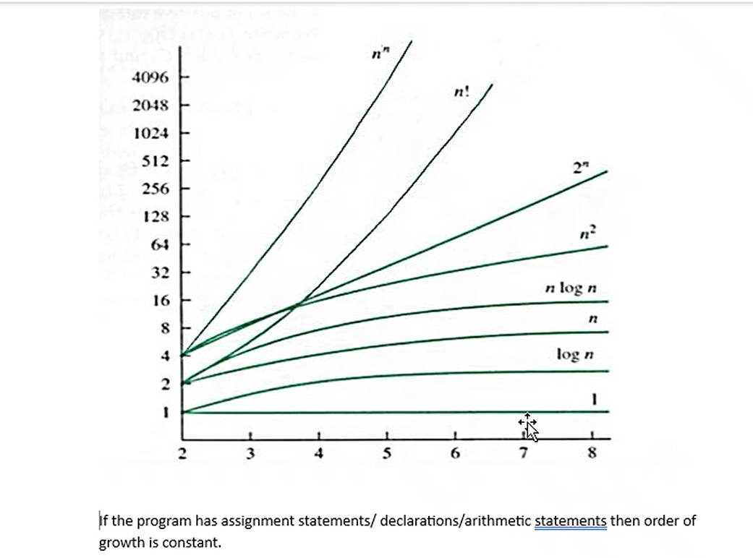
  + How measurement of code/logic is done
    - 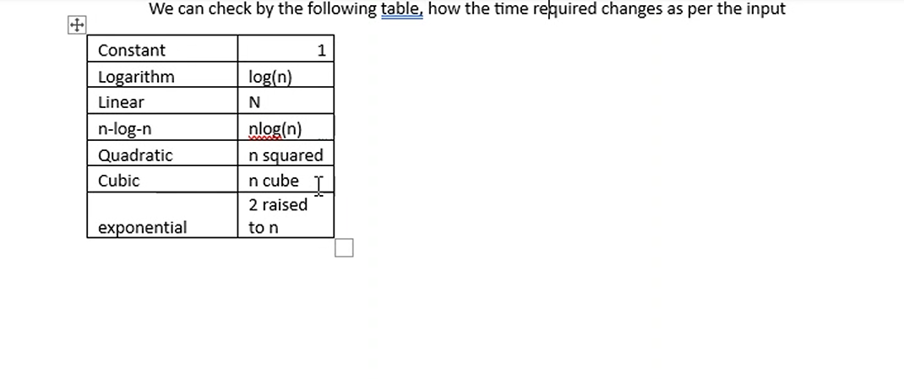
  + [23, 34, 56, 12, 100, 120]
    - Search 23: best case: big omega
    - Search 12 : average case: big theta
    - Search 120 or 500(since 500 is not there): worst case: Big O
  + Big O Notation—Worst case
    - 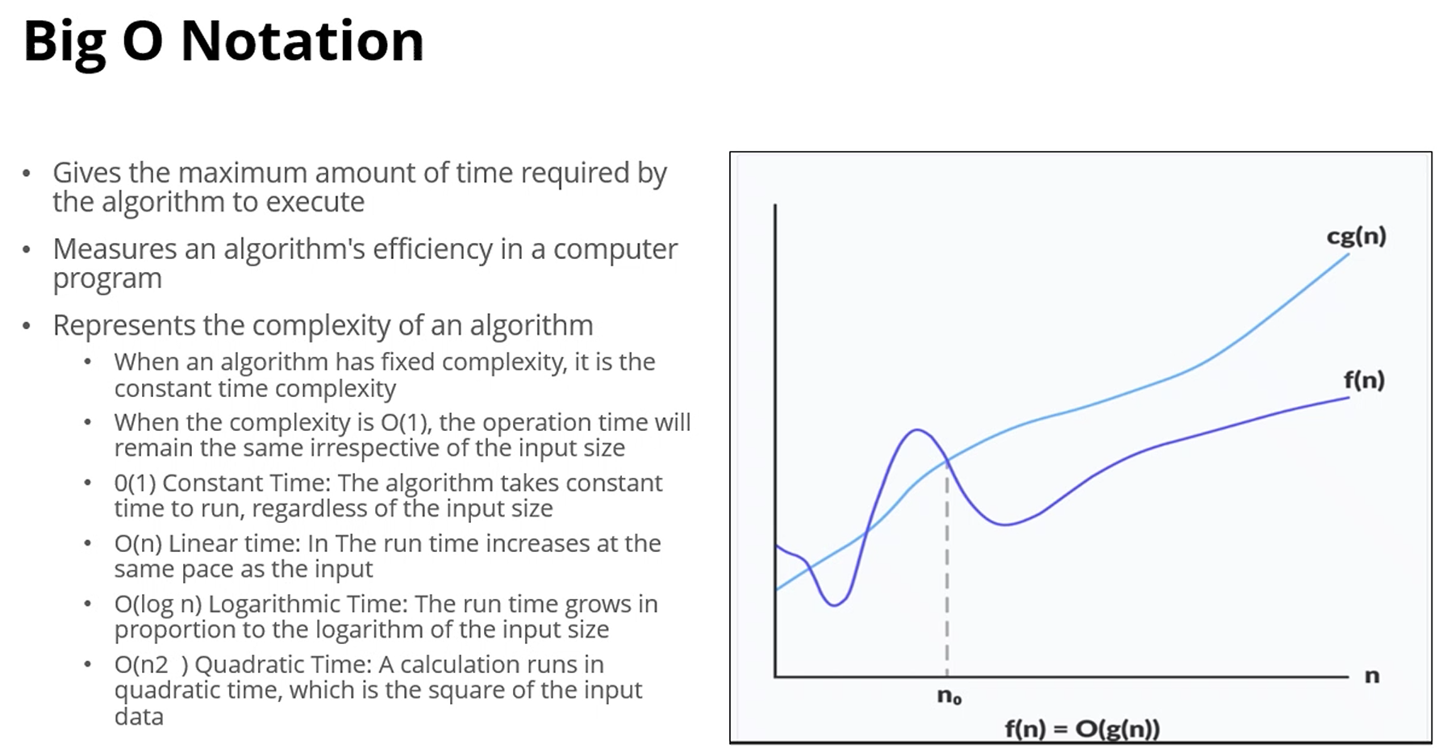
  + Big Omega Notation—best case
    - 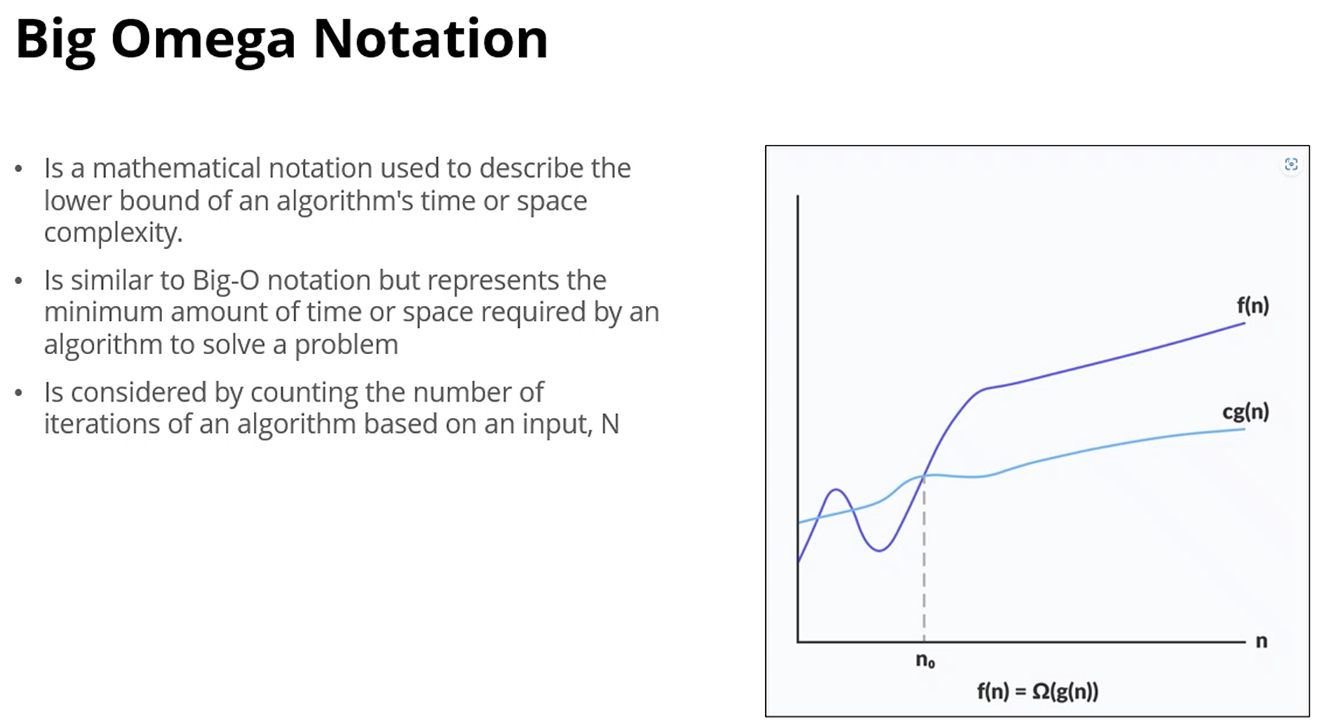
  + Big Theta Notation—average case
    - 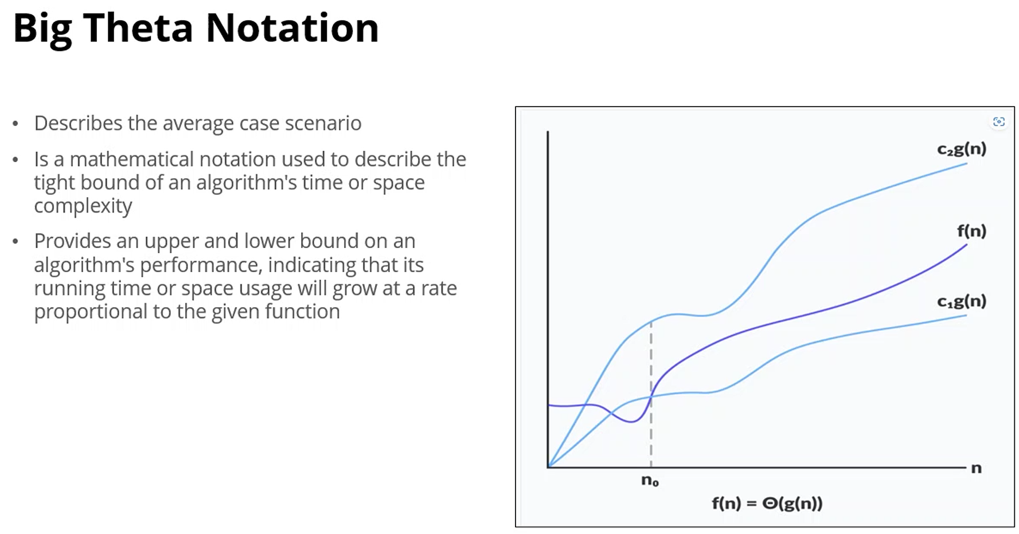
  + Types of Algorithms
    - 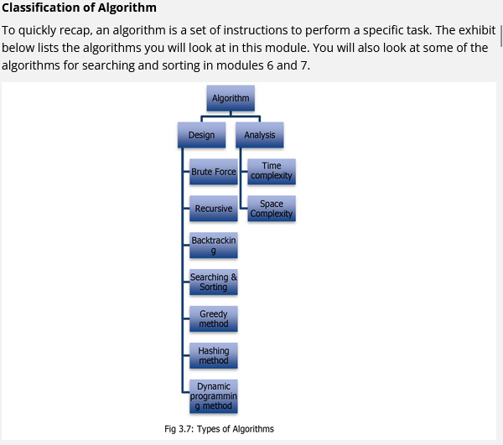
    - Brute Force Algorithm
      * 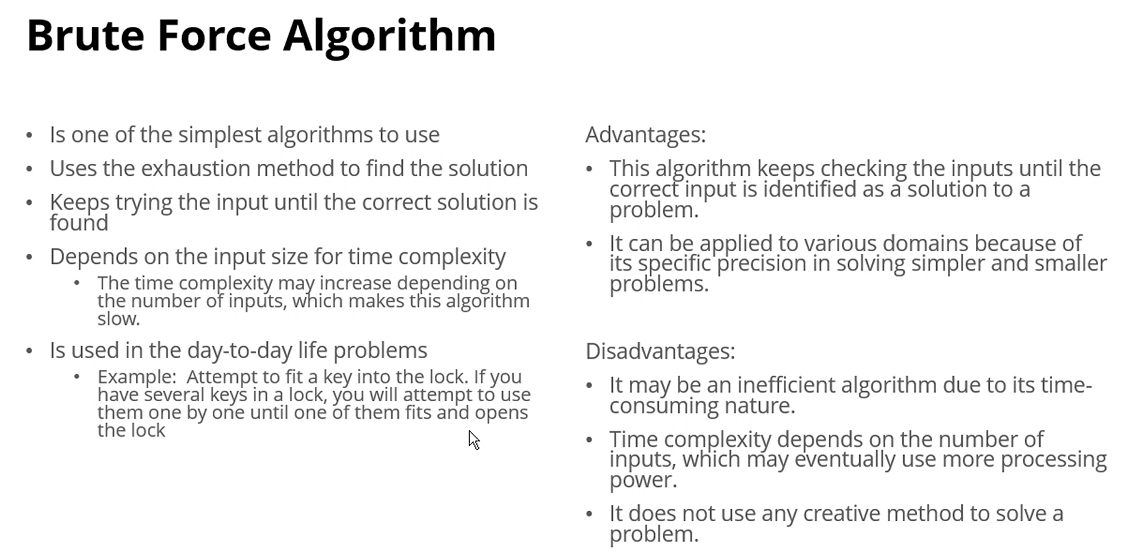
    - Searching
      * 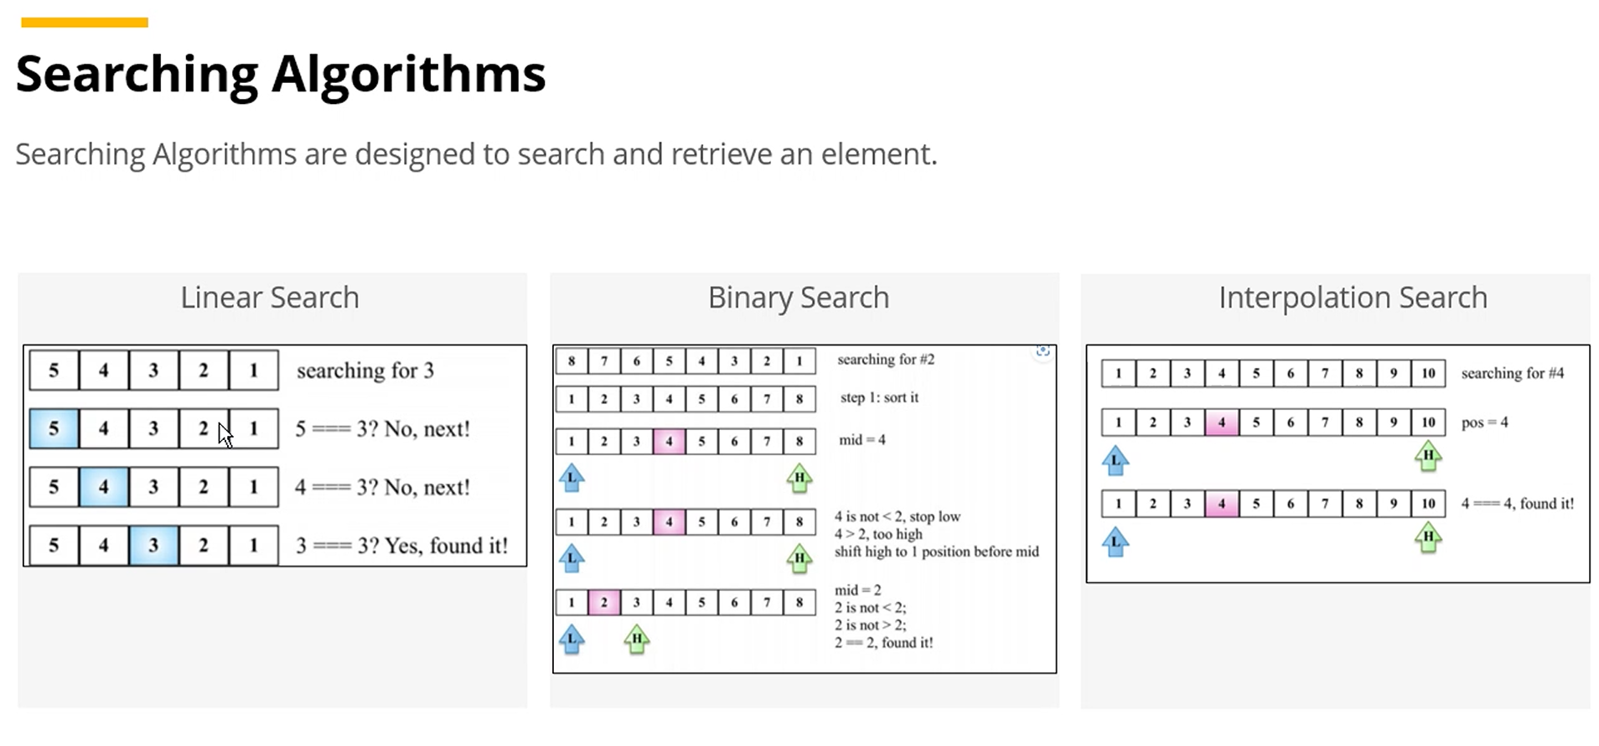
    - Sorting
      * 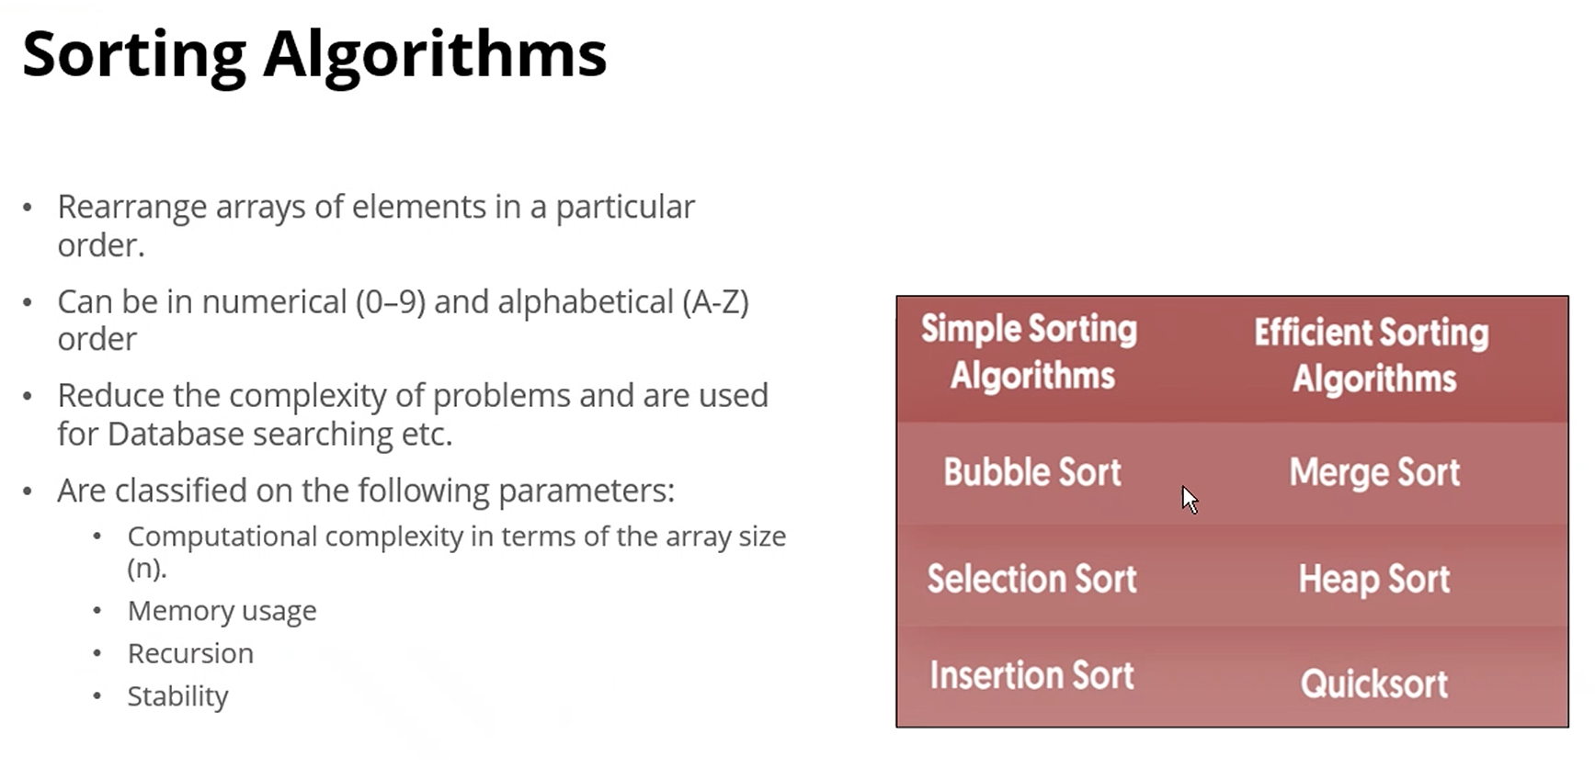
    - Hashing
      * 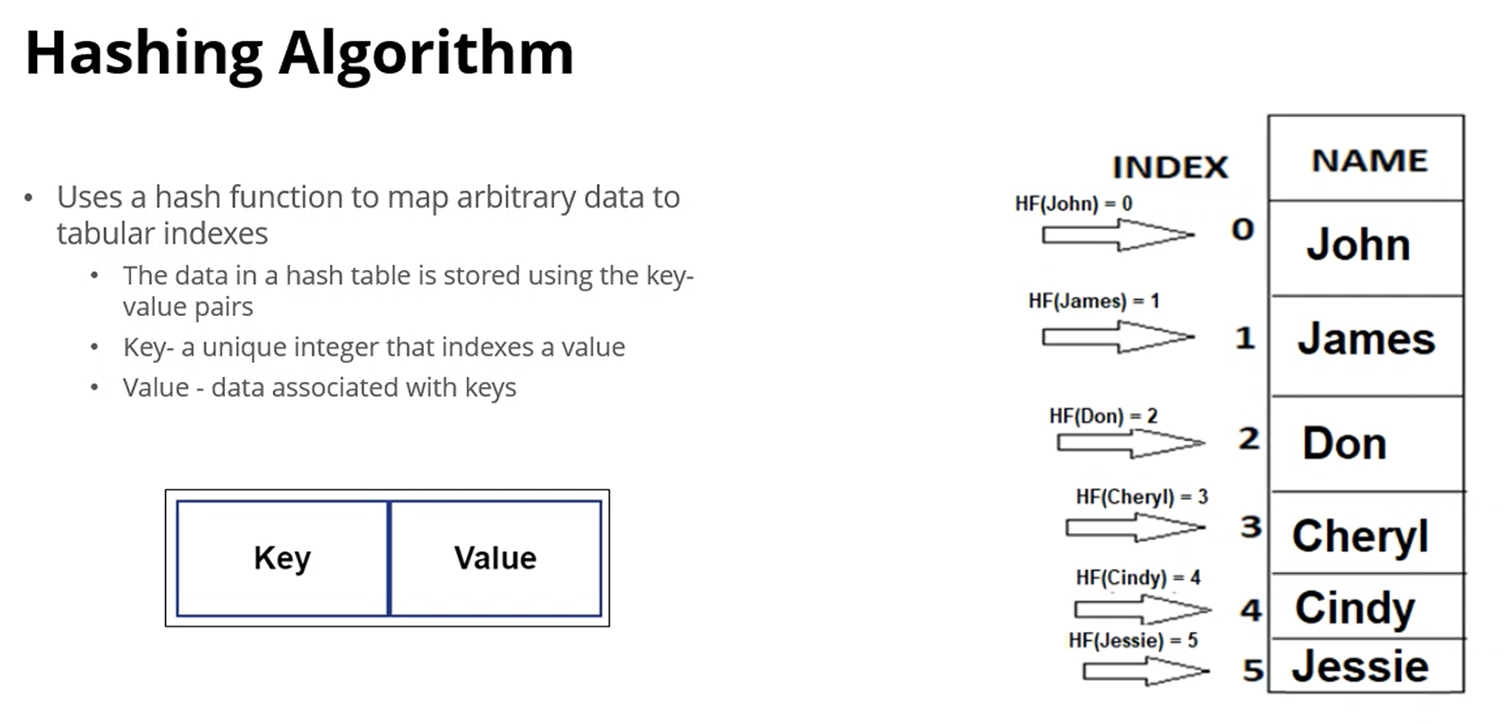
    - Divide and Conquer (DAC)
      * 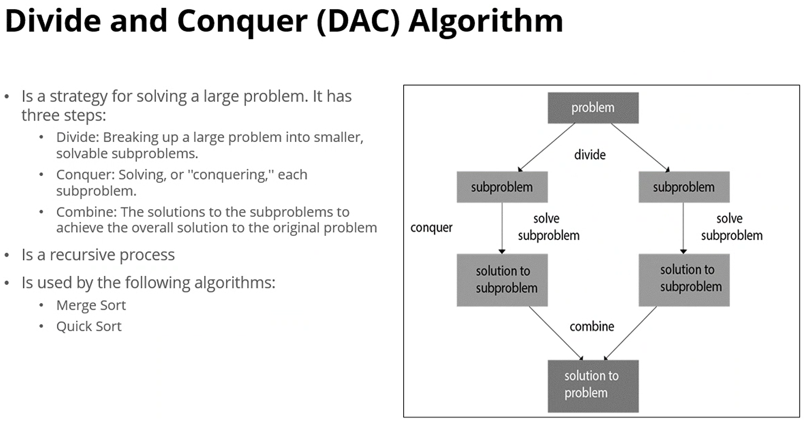
    - Introduction to Recursion
      * 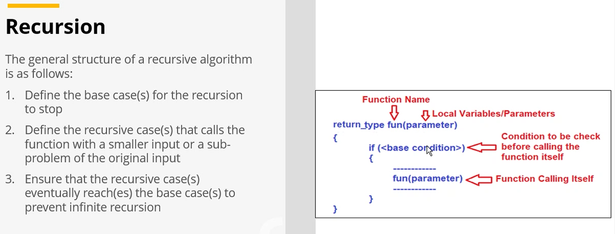
      * Memory-intensive process
      * Memory allocation takes place before the function is called
      * Fibonacci Series
      * 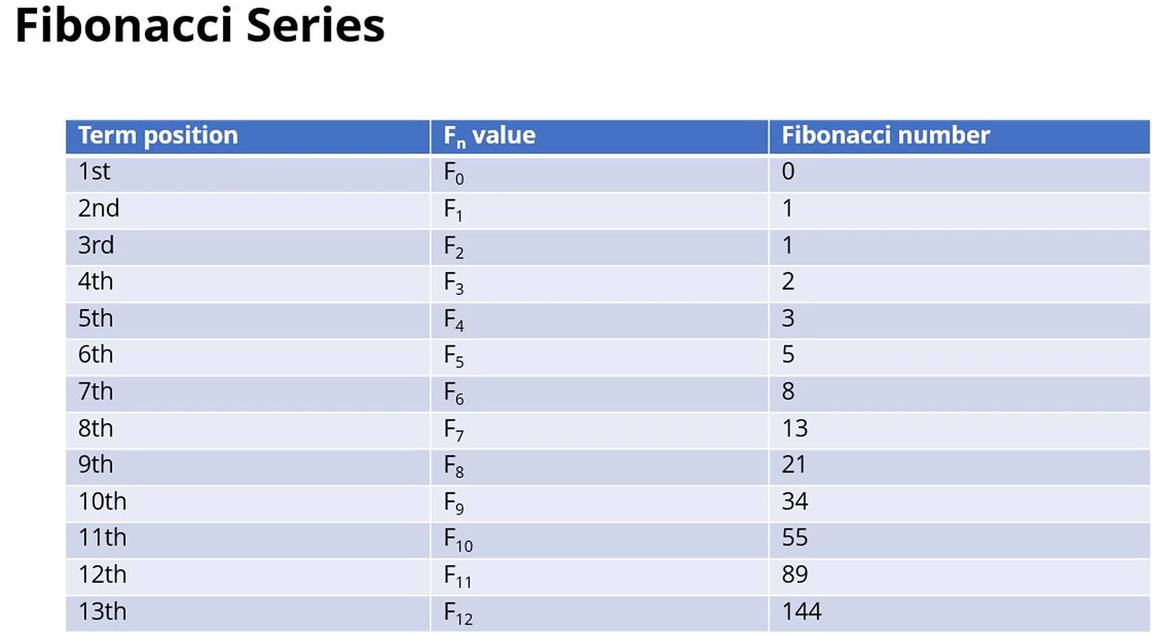
      * Fibonacci Tree
        + 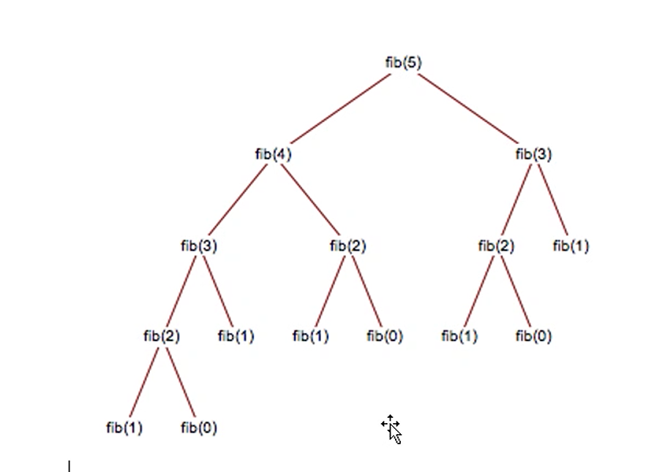
    - Dynamic programming—a way used in complex algorithms to solve them by dividing them into subproblems, solve the subproblems and storing its results. The result of the subproblem is further used to do next calculation. We avoid redundant computations or function calls this way

[**Module #6: Searching Techniques/Algorithms 13 Feb 2025**](https://utmssa.z19.web.core.windows.net/Module6.html)

* Linear
  + Done in a linear way from the beginning of the list
  + Time complexity O(N)
  + 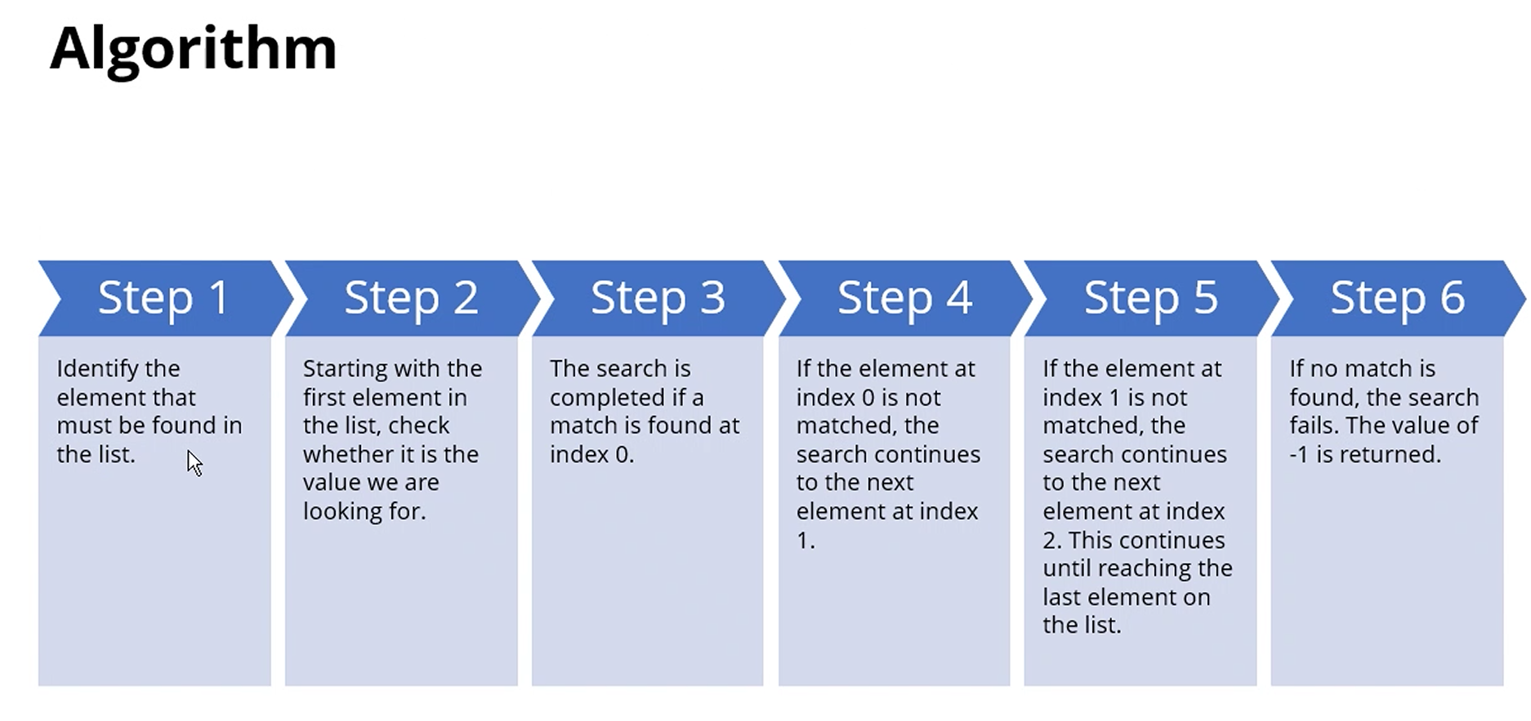
  + 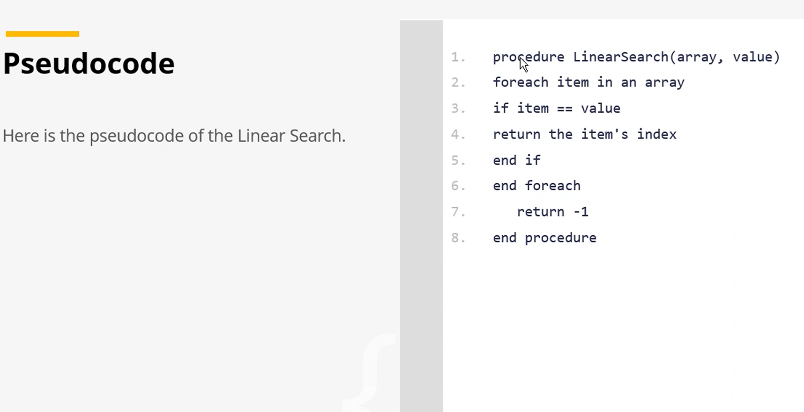
  + 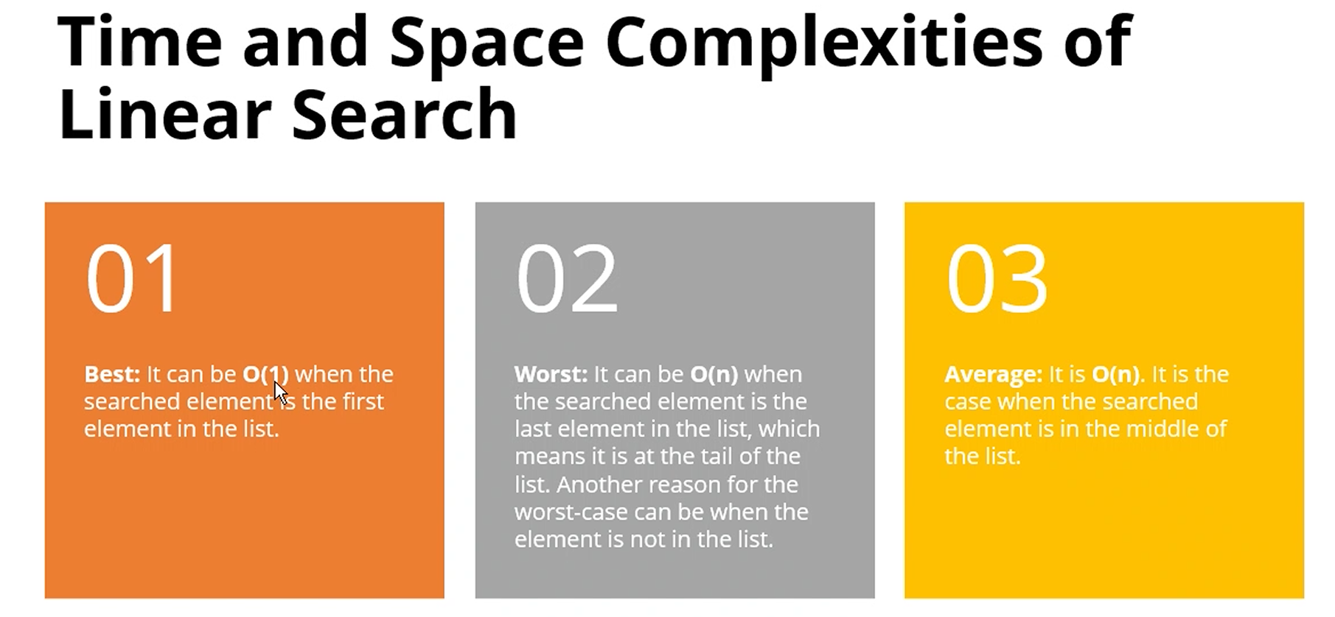
  + Best: O(1)—first element
  + Worst: O(n)—last element or not in the list
  + Average: O(n)—middle element
  + Improving Linear Search:
    - Transposition—Moving the element to the front of the list, one index at a time
    - Move to front—Directly swap the searched element with the element at index 0.
    - Hash Tables—Frequent searches you need to perform, hash tables to map every element from the array or list to its position. Then look at the hash table for the elements position
* Binary—works with sorted list only, is fast, uses divide-and-conquer (DAC) approach (divide array into 2 halves, search first and second halves (?)concurrently(?)) DEMO 0h46m AM 13 February 2025
  + Mid = [left + right] / 2 –left pointer/right pointer, at indexes 0 and array max respectively
    - * If array is 5 indexes, mid = [0 + 5] /2
      * Then array is cut in half, mid will either be mid = [0+2]/2 OR mid = [3+5]/2
    - If searched-for element is less than middle, right pointer moves to mid -1
    - If searched-for element is greater than middle, left pointer moves to mid +1
    - 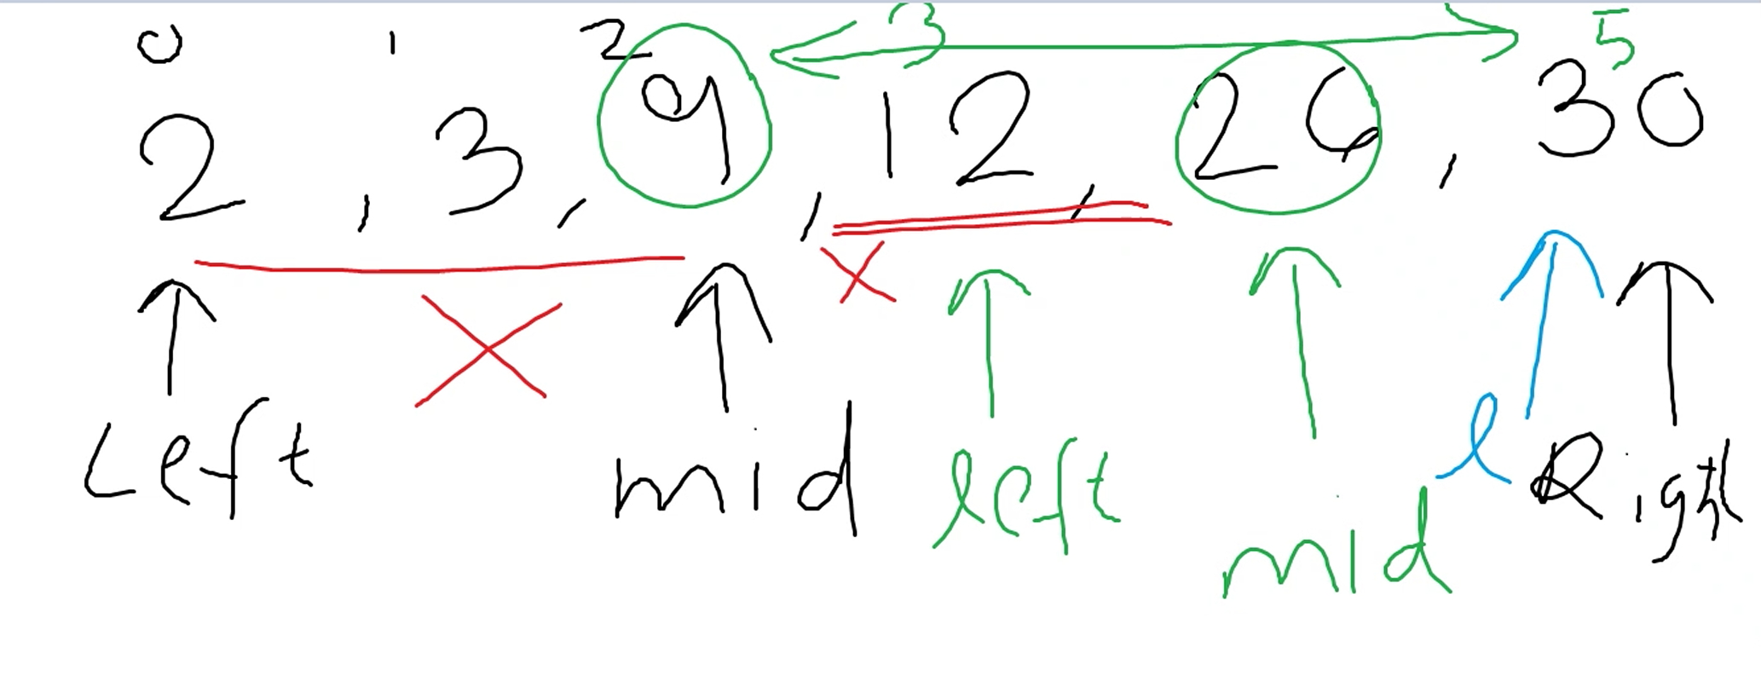
  + Keep dividing array, keep updating left/right pointer accordingly
  + 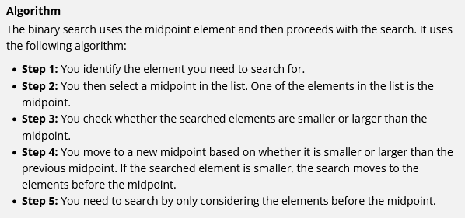
  + 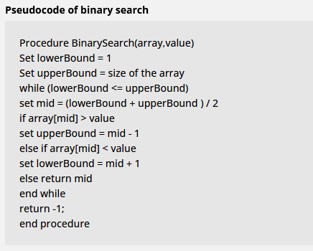
  + MORE PSEUDOCODE
  + 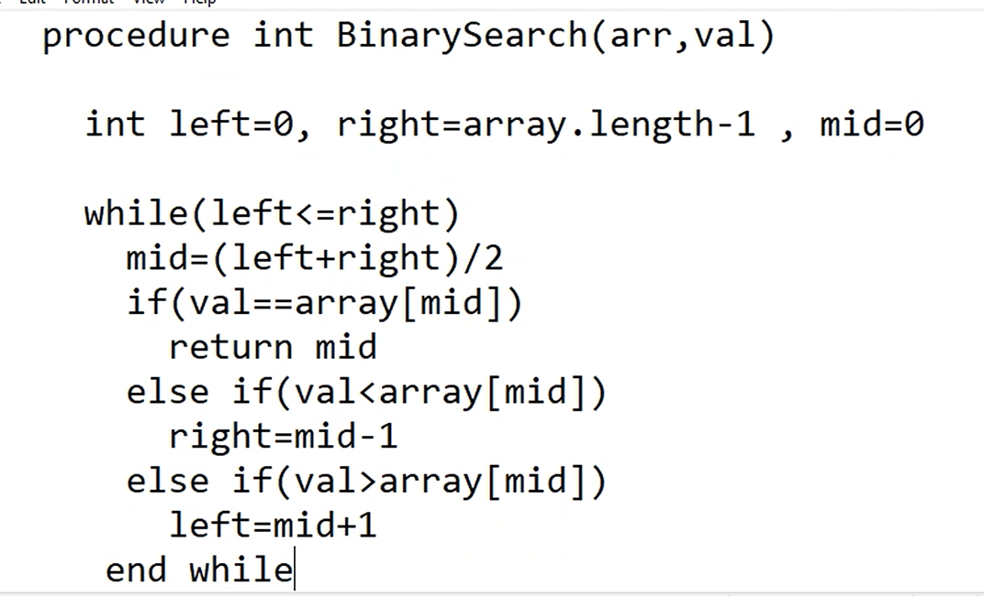
    - Return -1 (after end while)

[**Module #6: Linked Lists 18 Feb 2025**](https://utmssa.z19.web.core.windows.net/Module6.html)

* 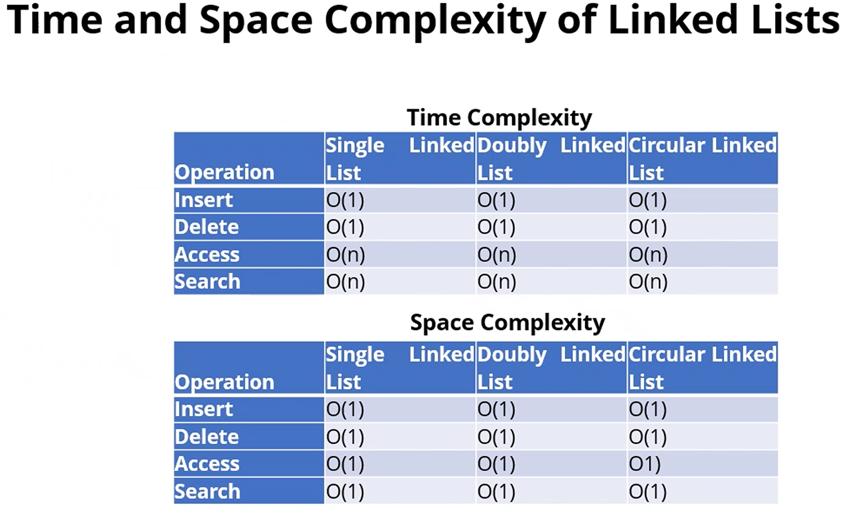
* 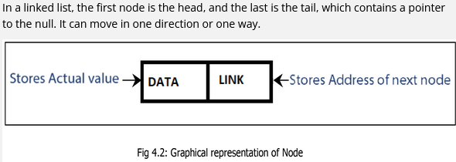
* 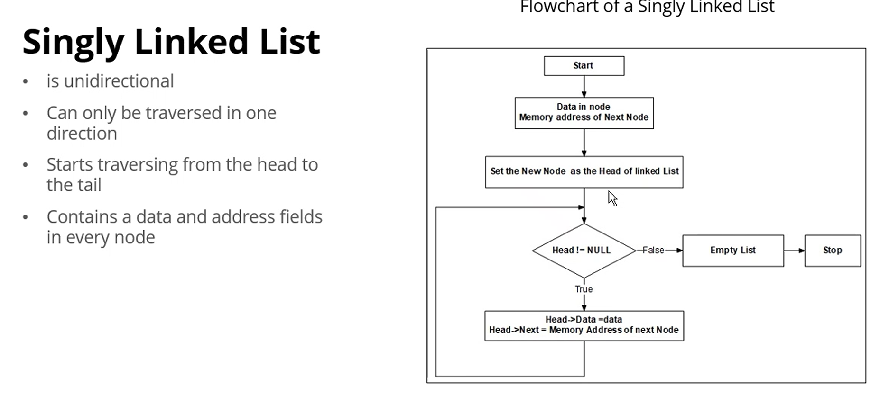
* 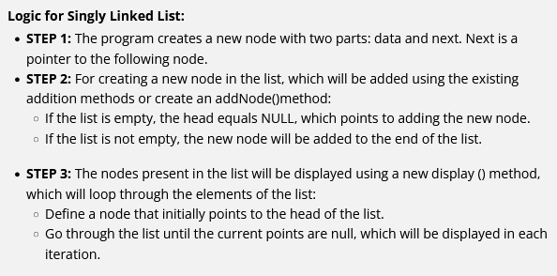
* 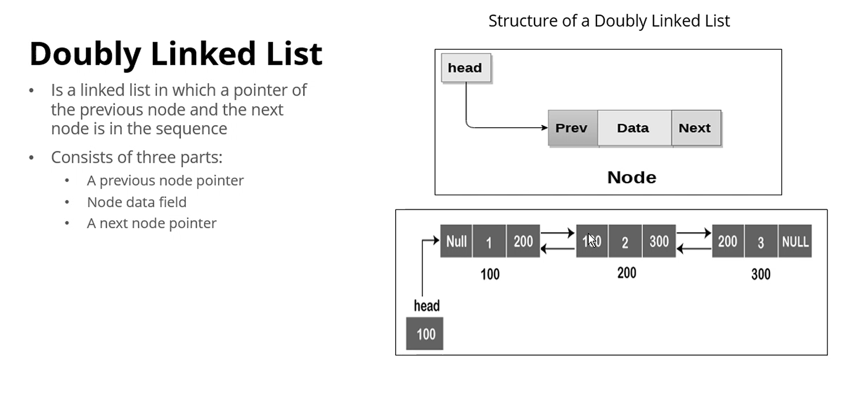
* 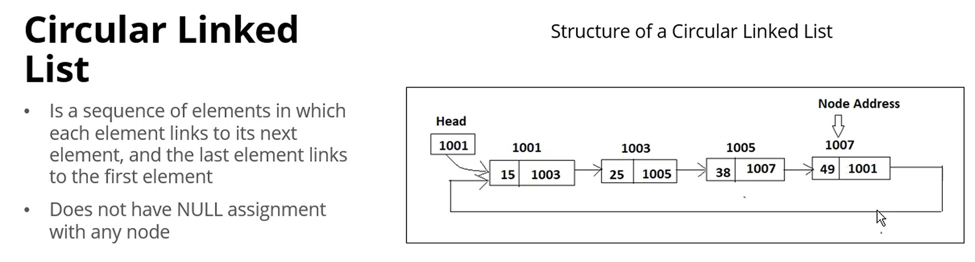
* Where would you use a Linked List? Applications:
  + Image viewer (preview previous/next image, double linked for example)
  + Previous and next pages (like in a browser, double linked)
  + Music player
  + GPS Navigation systems
  + Robotics (controls, store commands in a linked list)
  + Task scheduling

[**Module #: Stacks and Queues 19 Feb 2025**](https://utmssa.z19.web.core.windows.net/Module6.html)

* Stack—Linear collection of items which can be represented as vertical stacking. It is based on LIFO principle
  + Push, pop, peek (reading topmost, but not removing)
  + Applications:
    - Editor: undo operations
    - HTML documents
      * <p> Hello
    - (3+4)*5, evaluate arithmetic expressions
    - Parenthesis matching
    - Recursion (memory stack)
  + Implemented using Arrays

[**Module #: Sorting Techniques 19 Feb 2025**](https://utmssa.z19.web.core.windows.net/Module6.html)

* Bubble sort—stable (relative positions of numbers will remain the same); space complexity O(1)—does not require extra space for sorting elements—time complexity O(N) in best-case scenario and O(N2) in average and worst-case scenario
  + Compare consecutive elements
  + If left element > right side element, swap the elements
  + Continue till end of array and perform several passes
  + 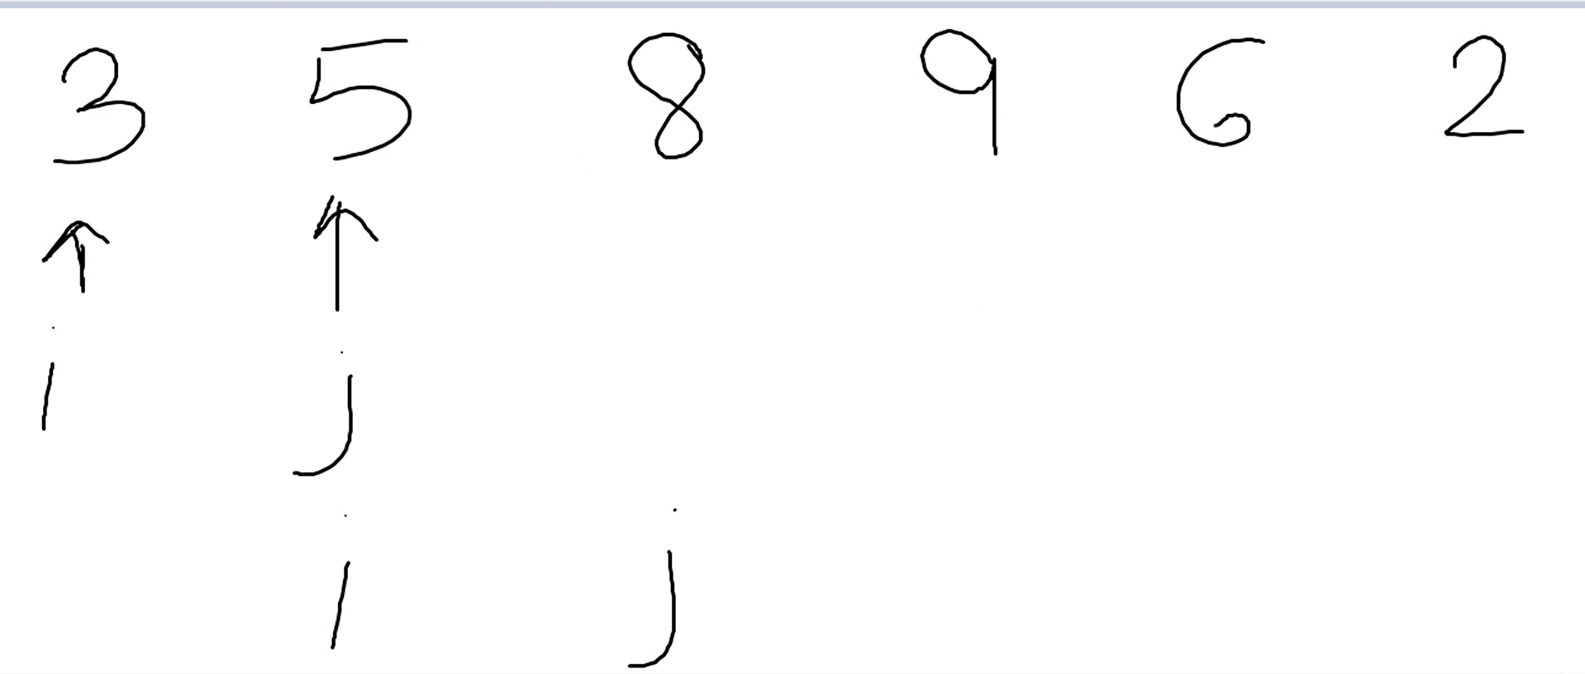
  + 9 and 6 will swap, then it will turn into:
    - 3-5-8-6-9-2
    - Then compares 9-2
      * 3-5-8-6-2-9
        + 9 has been “bubbled” to the end
    - Requires another pass but will only focus on 3-5-8-6-2 since 9 was bubbled
  + Implementation will require a nested loop
  + Is slow, won’t be using in any “real life situations” but is easy to implement
  + BubbleSort(int[] A)
  + {
  + temp = 0 //used for swapping
    - for (int pass = A.length-1 ; pass >= 0 ; pass--)
      * For(int I = 0; i < pass; i++)
        + If (A[ i ]> A[i+1])

swap

* + }

[**Module #5: Queues 20 Feb 2025**](https://learn.educate360.com/learn/course/mssa-pcad16-1/data-structures-and-algorithms-week-5/week-5?client=mssa&page=3)

* *Queue*—A collection of items in a linear way which follows the FIFO principle (opposite of stacks, LIFO)
* Items are added from the rear end and removed from the front end
* Applications:
  + Customer call queue
  + Printers
  + Shared resource access
  + Web servers, http q (each http request goes into the queue then the web server shows the web page to the customer based on the order)
* Uses two pointers: Front and Rear
* Empty queue = Front and rear = -1
* *Operations:* Enqueue, Dequeue
  + First, Length, IsEmpty
* Arrays vs Linked List:
  + Arrays: fixed size
  + Linked List: dynamic size
  + Q or stacks with arrays: Non-dynamic
  + Q or stacks with Linked List: Dynamic
* Insertion operation—Enqueue()
  + Adding numbers goes from the rear to the front
    - Increment the rear pointer
* Deletion operations—Dequeue()
  + First element in comes out first
    - Increment front pointer
    - Does not require a shifting of the array/queue
* Front +1 til the rear is the actual queue, the elements in the queue
* Treat the front and rear as limits
* Full Condition checked: Rear == Max-1
* Empty Condition checked: Rear = -1, Front = 0 (or -1?)
* f = -1 AND r = -1 ==🡺 empty queue
  + ADD numbers (callers) to the queue
    - Add the #10 to the queue—r = r + 1 ==== r = 0
    - Add the #12—r = 1
    - Add #13—r = 2
    - Add #15—r = 3
  + REMOVE numbers (callers) from the queue
    - F = f+1 === f = 0
    - F = f + 1 === f = 1(?)
      * Doesn’t remain 0 because you’re not shifting elements to the front, you’re just getting rid of them or returning them when they’re called
* 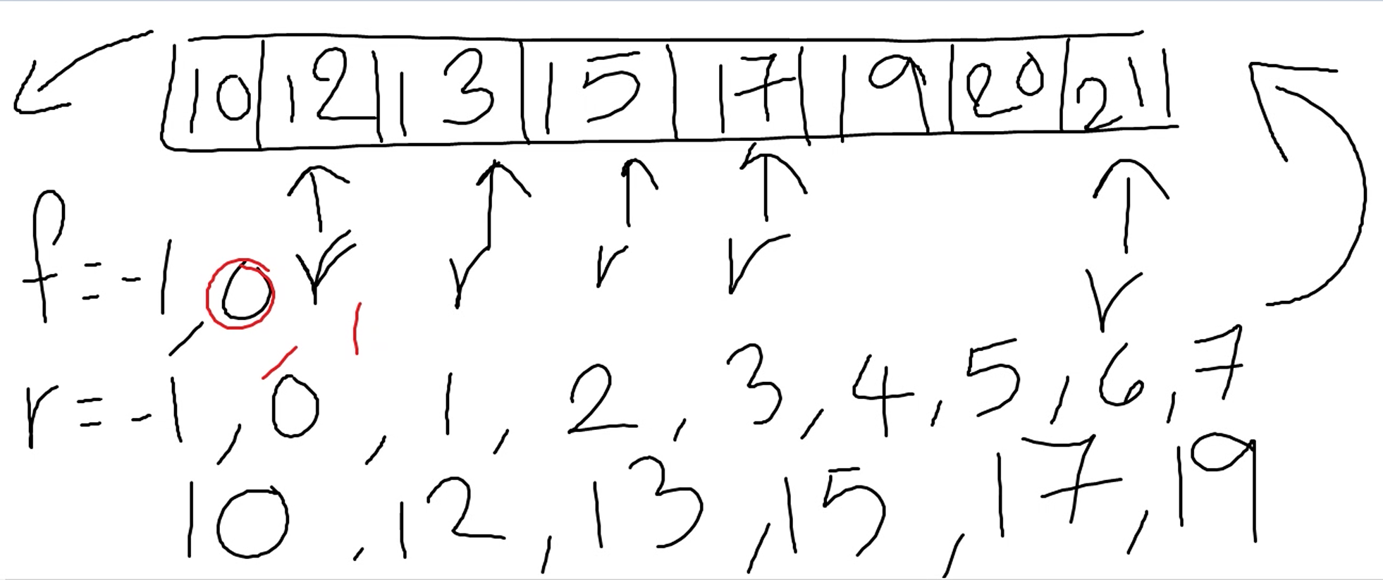
* 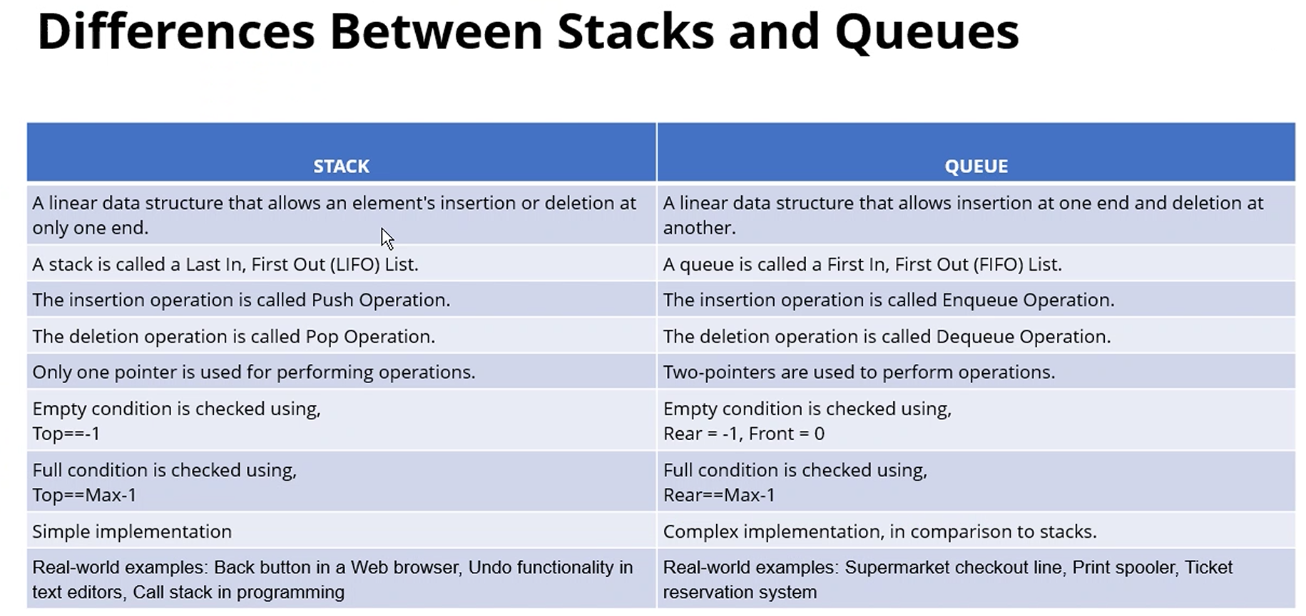

**[Module #7: Selection Sort 24 Feb 2025](https://learn.educate360.com/learn/course/mssa-pcad16-1/data-structures-and-algorithms-week-7/week-7?client=mssa&page=1)**

* Unstable, O(n^2) time complexity
* Easy process, easy to implement
* 1. Select minimum element from the collection
* 2. Place selected element in its appropriate spot, swap as needed
* 3. Apply this technique multiple times (n-1)
* 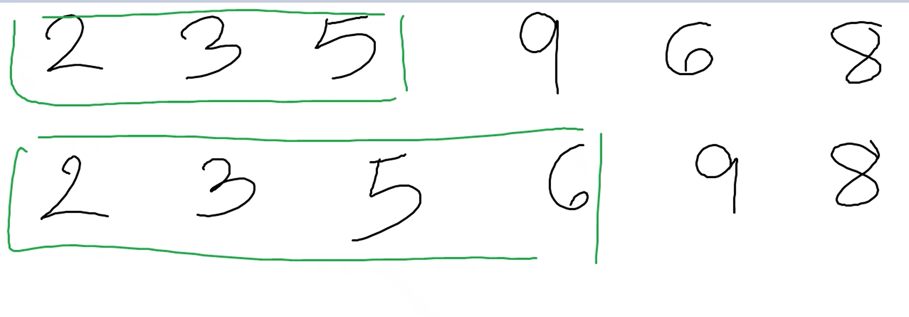
* …up to this point, 2-3-5-6 had been swapped around to get to their position and should not be touched to swap, since they’re in order already
* Next step: select minimum element from collection (8, step 1)
* Swap 8 with 9 to put it in the appropriate spot (step 2)
* This will be the last swap required (n-1 times)
* *Another example: 23, 46, 12, 2, 90*
  + Find minimum element first—2
    - #2, should be in #23’s position, swap them
      * 2, 46, 12, 23, 90
  + Find next minimum element—12
    - Swap 12 and 46
      * 2, 12, 46, 23, 90
  + Find next minimum element—23
    - Swap 23 and 46
      * 2, 12, 23, 46, 90
  + Find next minimum element—46
    - Already in position, doesn’t require a swap
      * *Prevent it from swapping with itself*
  + 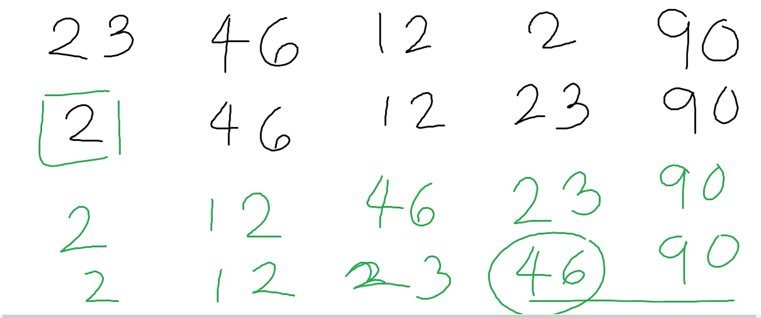
* Can be while loop, or for loop (nested for loop)

**[Module #7: Insertion Sort 24 Feb 2025](https://learn.educate360.com/learn/course/mssa-pcad16-1/data-structures-and-algorithms-week-7/week-7?client=mssa&page=1)**

* Stable
* O(n^2) time complexity
* 1. Insert 1 element from the left at a time
* 2. Insert this element in its proper position comparing to its right element
* 3. After the insertion, every element to its left will be sorted
* Can use for loop with while loop inside it
* Use a variable to track position

**[Module #7: Shell Sort 25 Feb 2025](https://learn.educate360.com/learn/course/mssa-pcad16-1/data-structures-and-algorithms-week-7/week-7?client=mssa&page=1)**

* Works in-place
* Time complexity O(nlog(n))
* Unstable
* Sorts the elements that are far apart from each other and successively reduces the interval between the elements to be sorted
* Based on insertion sort
* 1) A gap is calculated (n/2)—gap is the space *between* elements
* 2) Select an element from index 0 and compare with element after the gap. Swap as needed
* 3) Comparison is done on both left and right sides
* 4) Reduce gap by half in next round and continue steps 1-3
* 5) When gap is 0, we stop
* 3 5 8 9 6 2
* N=6
* Gap = n/2 = 6/2 = 3
* While loop
* 3 is compared to the number after the gap, 9
* 3 < 9, no change
* 3 is compared to any numbers on the left hand side, but there is nothing on the left, no change
* 3 5 8 9 6 2
* Counter increments ++ from 3 to 5
* Gap = 3
* 5 compared to # after the gap, 6
* 5 < 6, no change
* 5 compared to left hand side, (?)nothing to compare(?), no change
* 3 5 8 9 6 2
* Counter ++
* 8 compares to 2
* 8 > 2, they swap 🡪 3 5 2 9 6 8
* Can’t compare left side, not enough gaps
* Counter ++
* 3 5 2 9 6 8
* Can’t compare to right side, not enough gaps
* Compares to left side by 3 gaps—9 vs 3, 3 is already < 9, no swap
* Continue until no elements on right side after the gap
* Divide the gap by 2
* Gap = 3/2 = 1.5 = 1
* Start over from 1st element
* Continue until gap = 1
* Pseudocode
  + h = interval, n = size of array
  + for h from n/2 to 1, do:
    - swap the elements using the selected interval
    - reduce the interval until it becomes 1
    - sort using insertion sort
  + return sorted array

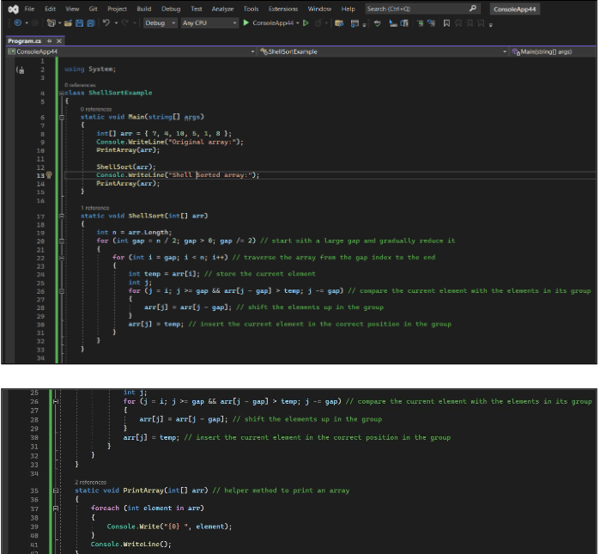

[Module #: Trees 25 Feb 2025](https://utmssa.z19.web.core.windows.net/Module8.html)

* Non-linear data structure (ADT—Abstract Data Type) which can represent hierarchical relationships
* Each tree has a starting point (node)—called a root
* Always start at the root when traversing the tree
* Edge—connect nodes in a tree (the line between the nodes)
* Set of Nodes and Edge which represents the parent-child relationship
* *Nodes* = N
* *Edges* = N-1
* Terminologies:
* *Root*: Starting node with no parent
* *Siblings*: Children of same root or parent
* *Leaf Node/External Node*: Nodes with no children, end of tree
* *Non-Leaf Node/Internal Node:* Having 1 or more children; parent
* *Edge of tree:* a pair of 2 nodes (u, v) such that *u* is a parent of *v*
* *Path:* Sequence of nodes such that 2 consecutive nodes form an edge
* *Subtree:* Any node in a tree with its children
* *Height:* Number of edges to root
* *Level:* Number of nodes to root
* *Degree of Node:* Number of children a node has
* *Degree of Tree:* Maximum of degree of nodes (maximum number of children any node has)

Binary Trees

* 1) Every node has, at most, 2 children (0, 1, 2—0 = parent(?))
* 2) Every child as left / right
* 3) Degree of binary tree is 2
* Can be left or right skewed (heavier left or right side)
* *Proper Binary Tree:* Every node has either 0 or 2 children (full binary tree in the book)
  + 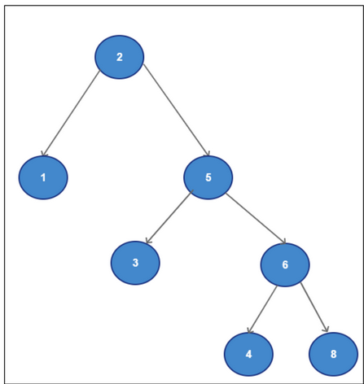
* *Full Binary Tree*: Every internal (parent) node has exactly 2 child nodes and all the leaf nodes are at the same level (perfect binary tree in the book)
  + 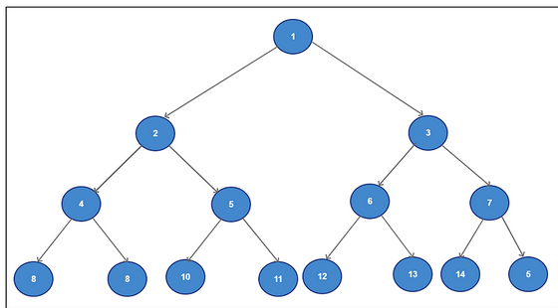
* *Complete Binary Tree:*
* Numbering of nodes is specific
  + Left to right, at each level (bottom to top? Top to bottom?), without a gap
* Number of children for each node are 0, 1, or 2.

Tree Traversal

* 1) *Level Order*: Difficult, time consuming, rarely done
* 2) *Pre-Order*: Visit root; visit left subtree recursively in preorder; visit right subtree recursively
  + 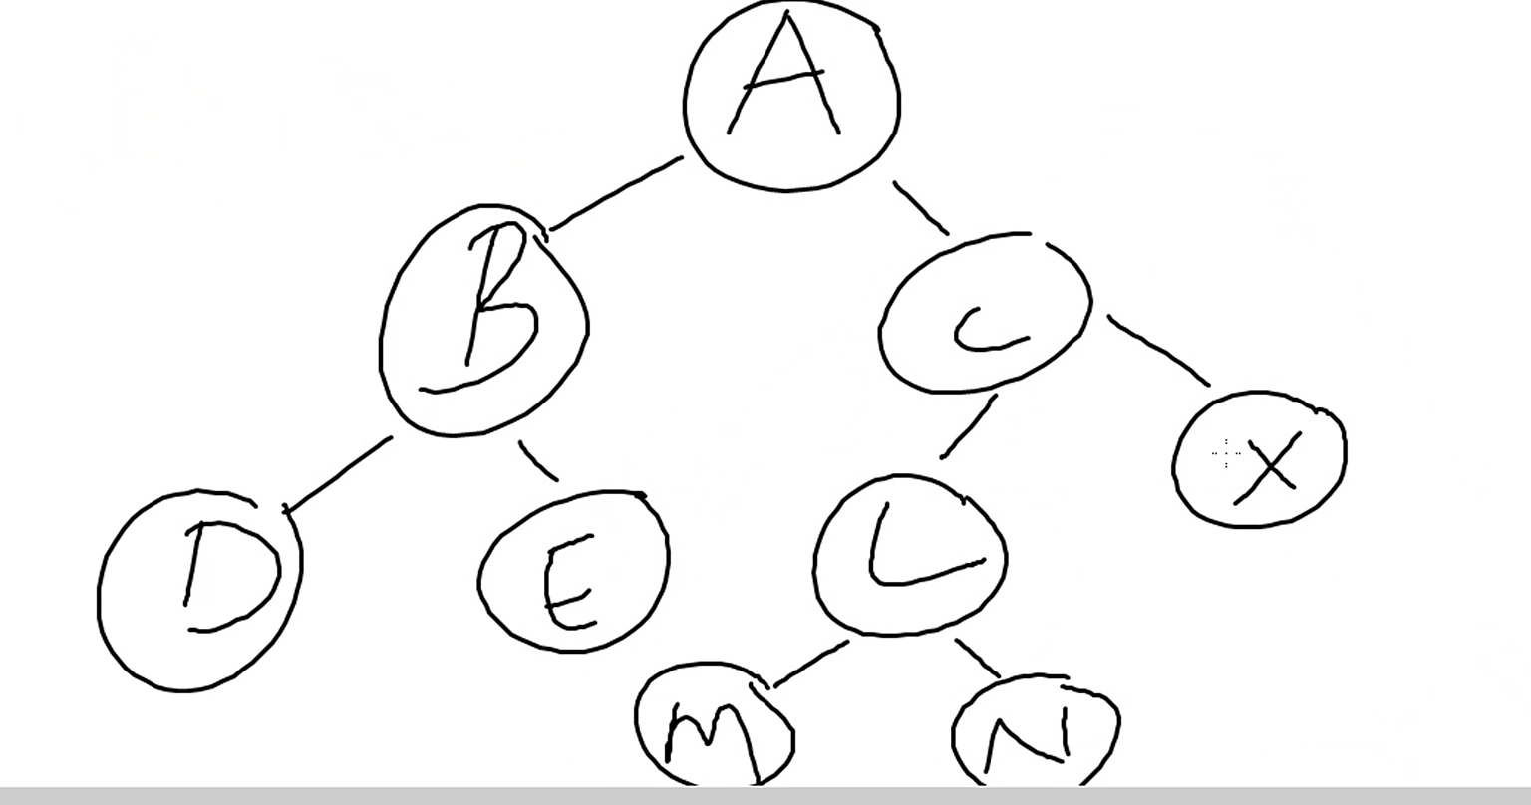
    - Order is: A B D E C L M N X
* 3) *In-Order:* Visit left subtree recursively; visit root; visit right recursively
  + 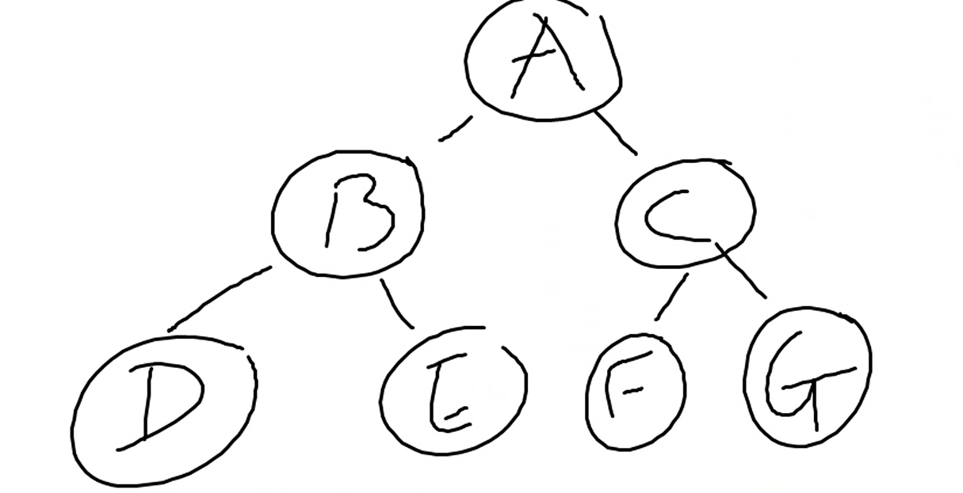
    - Order: D B E A F C G
      * (Left) D B E
      * (Root) A
      * (Right-Left) F C G
  + 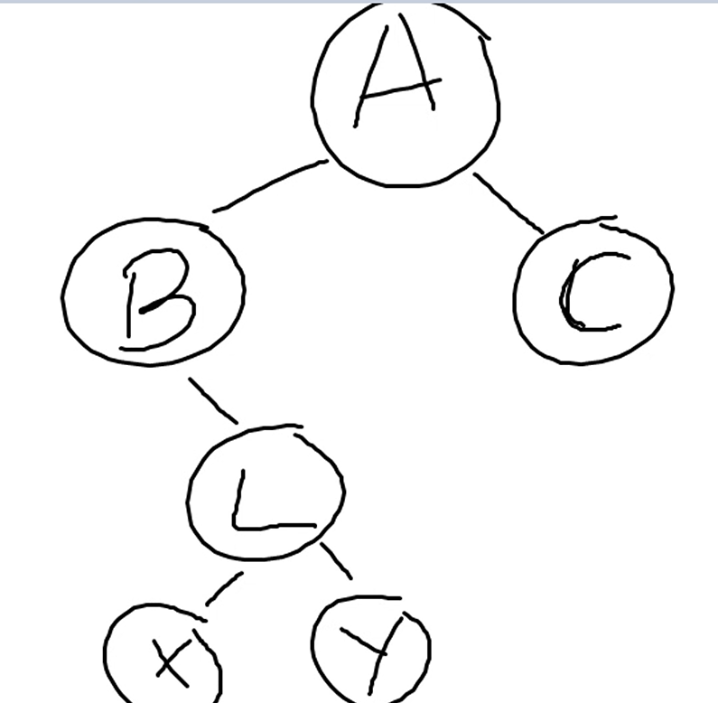
    - Order: B X L Y A C
  + 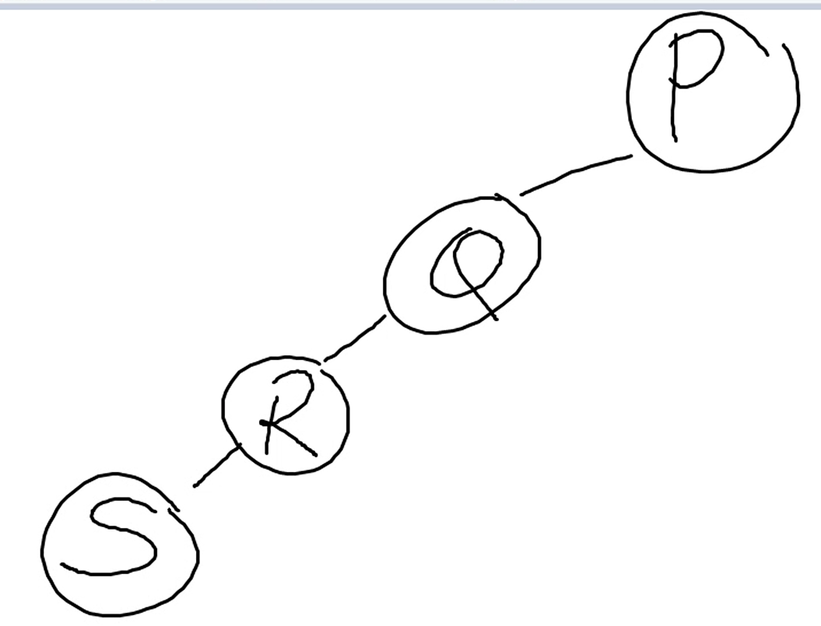
    - Order: S R Q P
* 4) *Post-Order*: Visit left subtree recursively; visit right subtree recursively; visit root
  + 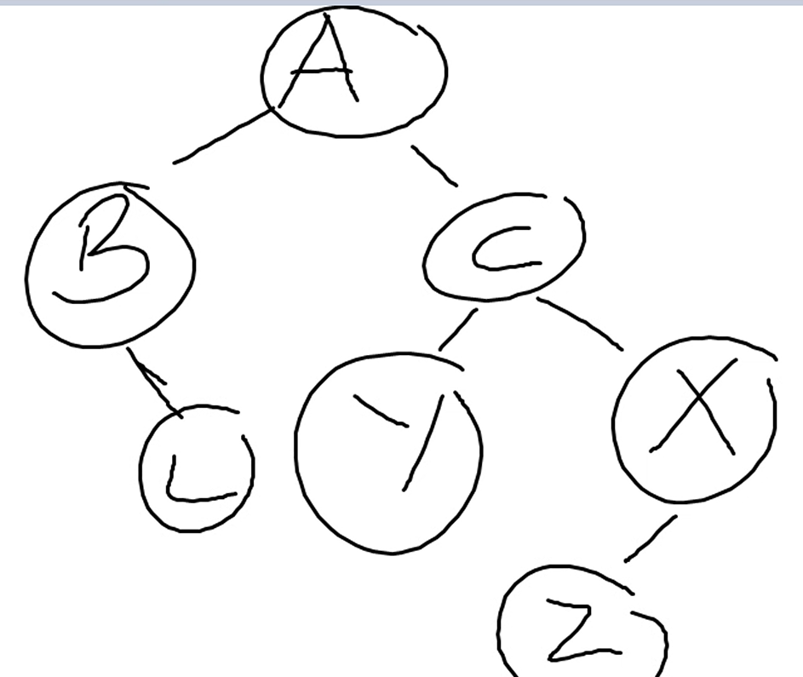
    - Order: L B Y Z X C A –Why not C X A?
      * ~~(Left) B Y Z~~
      * ~~(Right) L X C~~
      * ~~(Root) A~~
  + 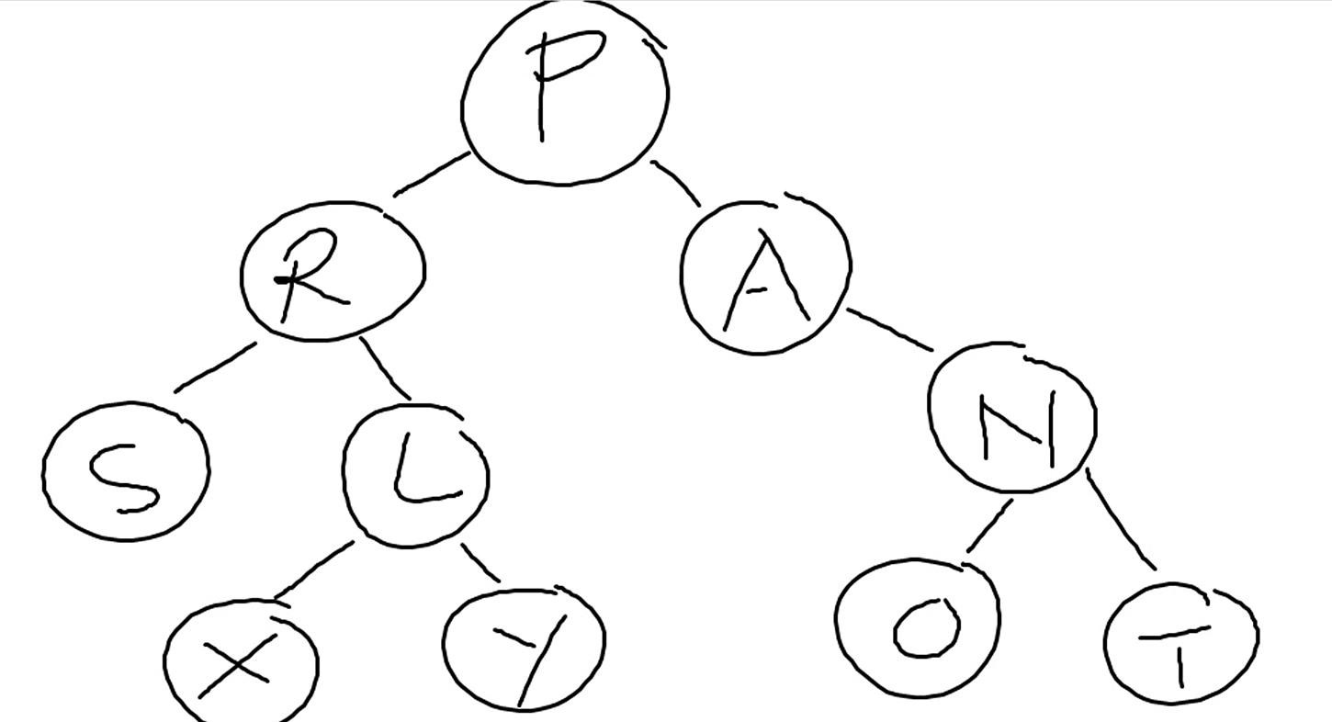
    - Order: S X Y L R O T N A P
* With operands: + a b—where + is the parent, a is left child, and b is right child
  + Pre-order: + a b
  + In-order: a + b
  + Post-order: a b +

Binary Tree Array Representation:

* 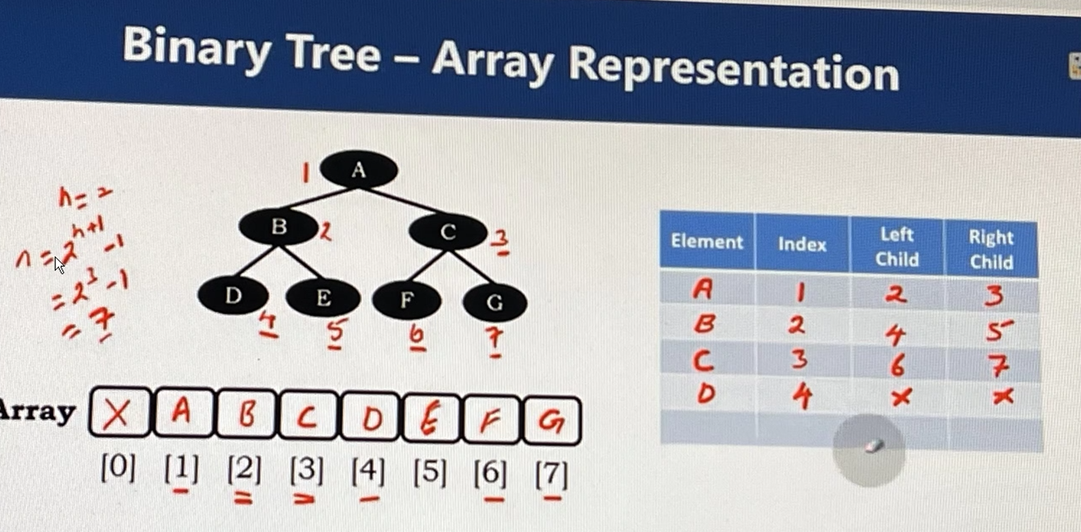
  + H = height (0-A, 1-BC, 2-DEFG)
  + 0th index is left “black”

Binary Tree Linked (List) Representation

* 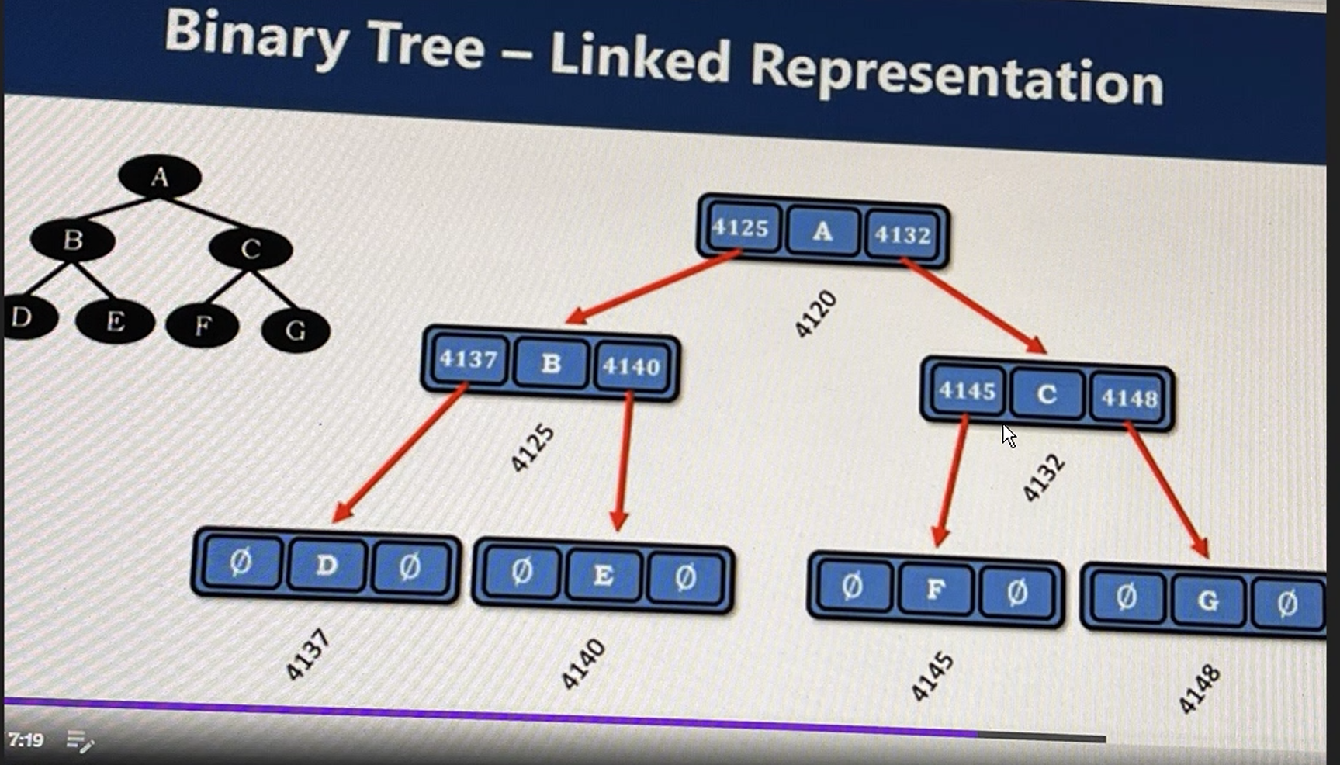
* Lll

Binary Search Tree

* Left nodes are smaller than the root and right nodes are greater than the root
* If you do an *In-Order* traversal in a binary search tree, you’ll get the data in a ascended sorted order
  + Left, root, right
* Cannot store duplicates
* 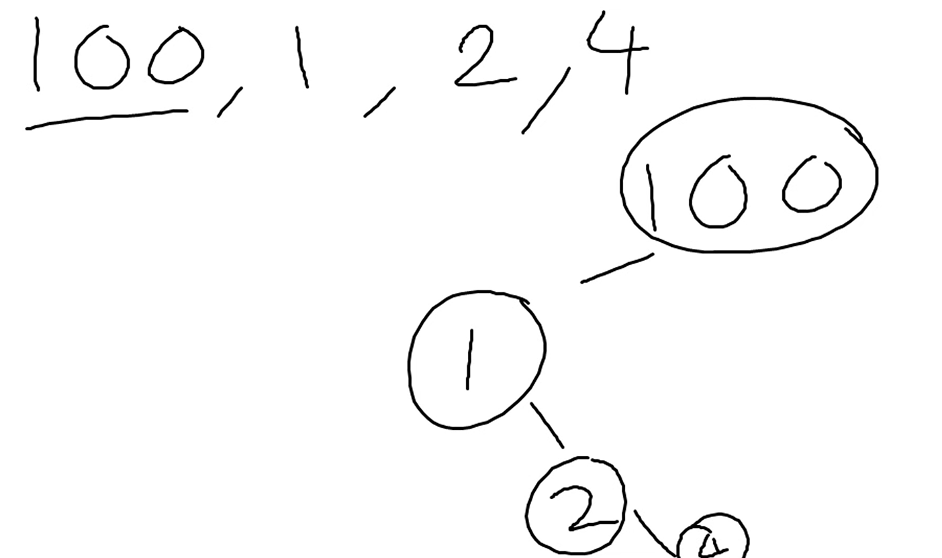

[Merge Sort:](https://utmssa.z19.web.core.windows.net/Module7.html) [Courseware Link](https://learn.educate360.com/learn/course/mssa-pcad16-1/data-structures-and-algorithms-week-7/week-7?client=mssa&page=1) [MSSA eBook Link](https://utmssa.z19.web.core.windows.net/Module7.html)

* Good sorting method, might be asked about in interviews
  + Merge sort, quick sort
* Time complexity: O(n log n)
* Space complexity: O(n)
* Stable
* Works well with larger arrays
* 1) Divide the list into small sub-parts such that there is only 1 element in the sub-part
  + 10 9 2 23 42
    - Divide array in half
      * 10 9 2 | 23 42
    - Divide first half into sub-parts
      * 10 | 9 2 | 23 42
    - Continue to divide
      * 10 | 9 | 2 | 23 | 42
* 2) Sort and merge the individual sub-parts back together
* 3) Recursive approach, Divide and Conquer
* Another example: Black—red—green
  + 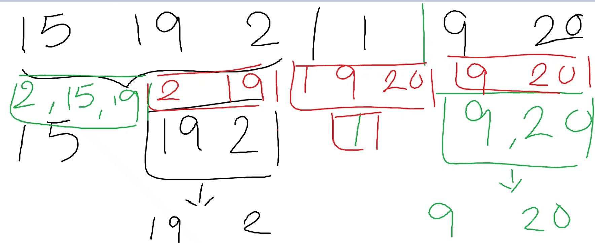
* Use 2 pointers/counters
  + Compare them
    - Place smaller one in the array
      * Increment pointer which was moved into array
  + 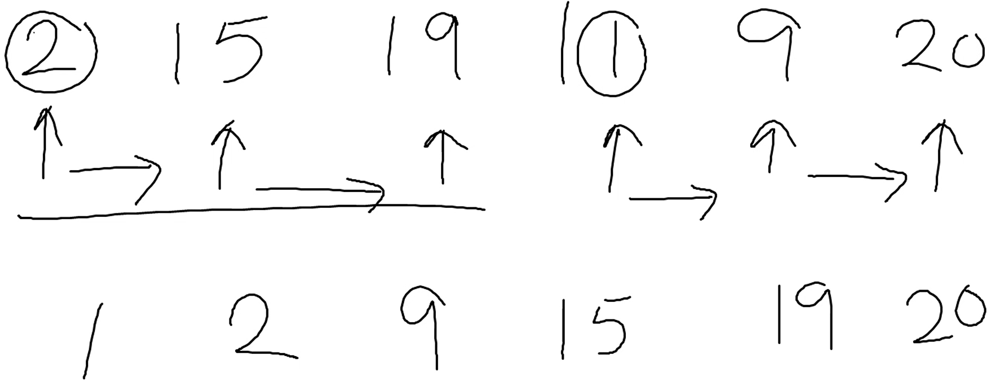
  + Very similar to the merge strings abc pqrs assignment (7.1b)
* Pseudocode:
  + Get left and right pointers
    - Left = 0
    - Right = length of array (array.Length)
  + Mid = (left + right) /2
    - 12 2 3 10 9 7
      * Left = 0 [12]
      * Right = 5 [7]
      * Mid = 2 [2]
  + Use recursion to continue to divide
    - Left = 0 (remains 0)
    - Mid = right (Mid becomes right)---no?
    - Right = mid (right becomes mid)
      * Only focusing on the left part, will do right later
    - Mid = (left + right) /2
      * Mid = 1 [3]
    - After left is completely divided up, move to right side
      * Left = mid+1

[**Module #8: Graph Data Structures - 3 March 2025**](https://learn.educate360.com/learn/course/mssa-pcad16-1/data-structures-and-algorithms-week-8/week-8?client=mssa&page=2) [**E-Book**](https://utmssa.z19.web.core.windows.net/Module8.html)

* Koenigsberg Bridge Problem
  + Leonhard Euler
  + 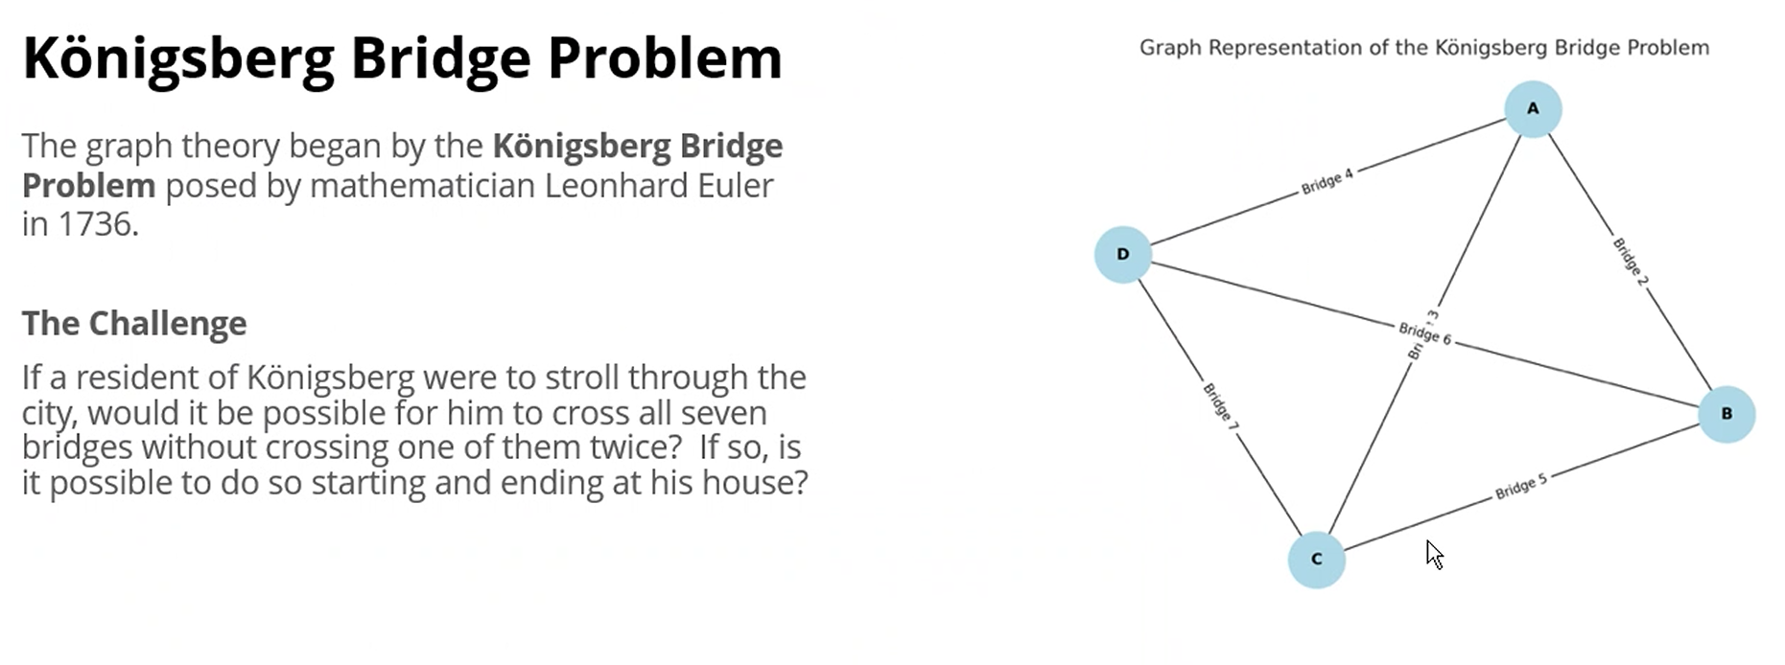
  + Check 0h 19m for missed slide
* *Vertex (Node)—*
  + 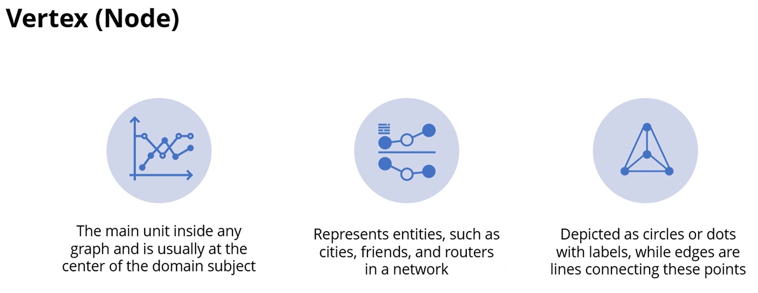
* *Edge (Link)—*
  + 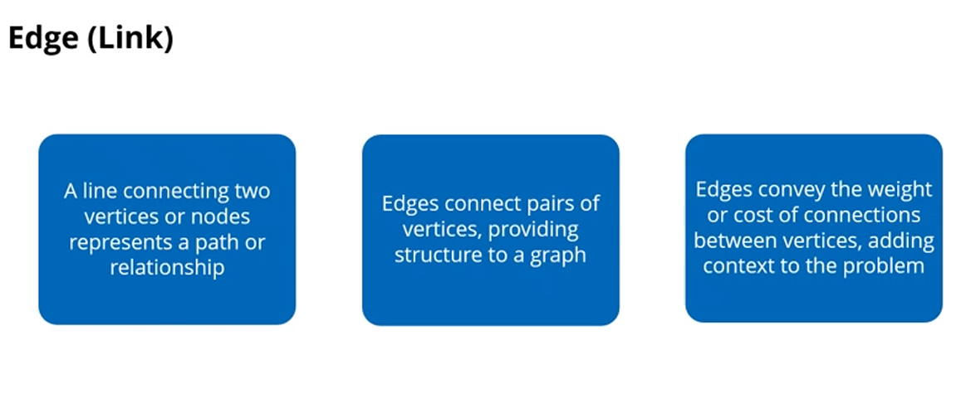
  + 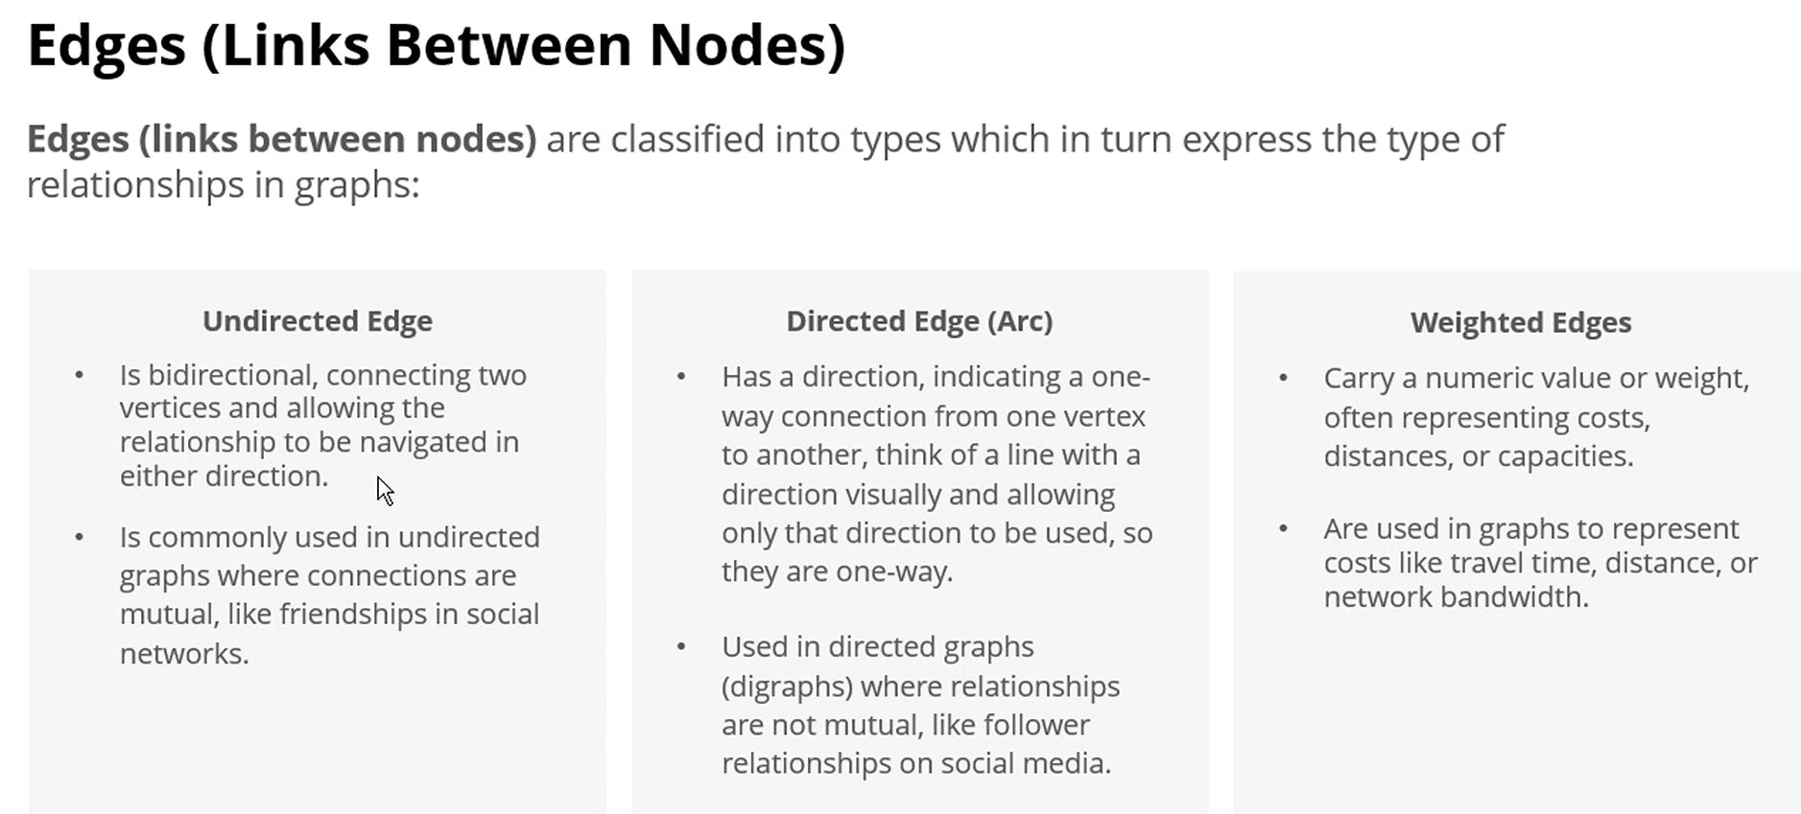
  + Unidirected, directed, weighted edges
* *Cycles—*
  + Business Salesman Problem
  + Example:
    - Task A dependent on B, B depends on C, C depends on A
    - No clear starting point, endless loop
* *Degree of Vortex*—l
  + 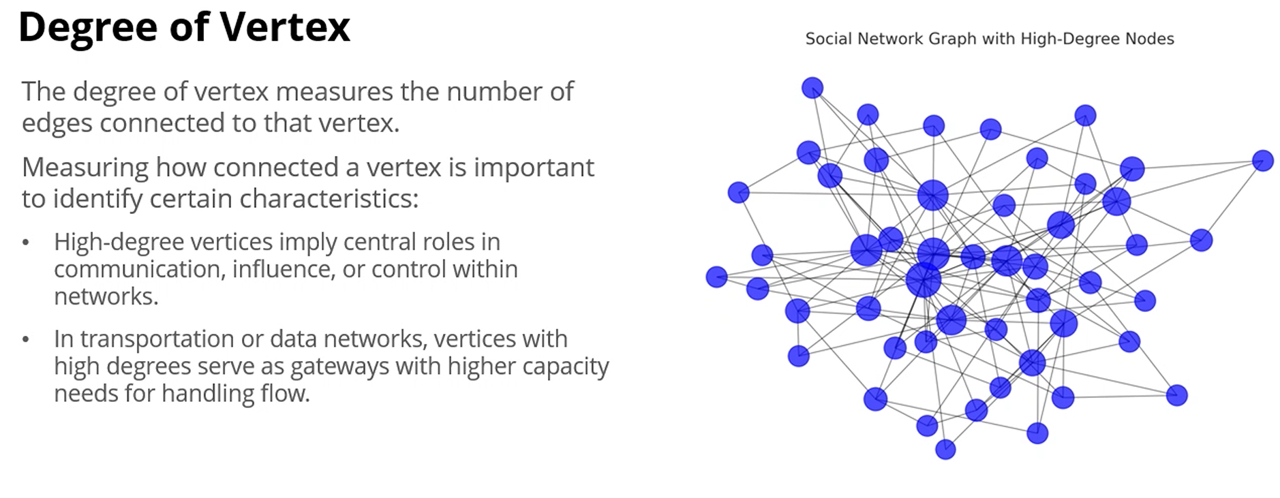
* *Out Degree—*Count of edges going outward from a vertex; only applies on directed graphs
  + 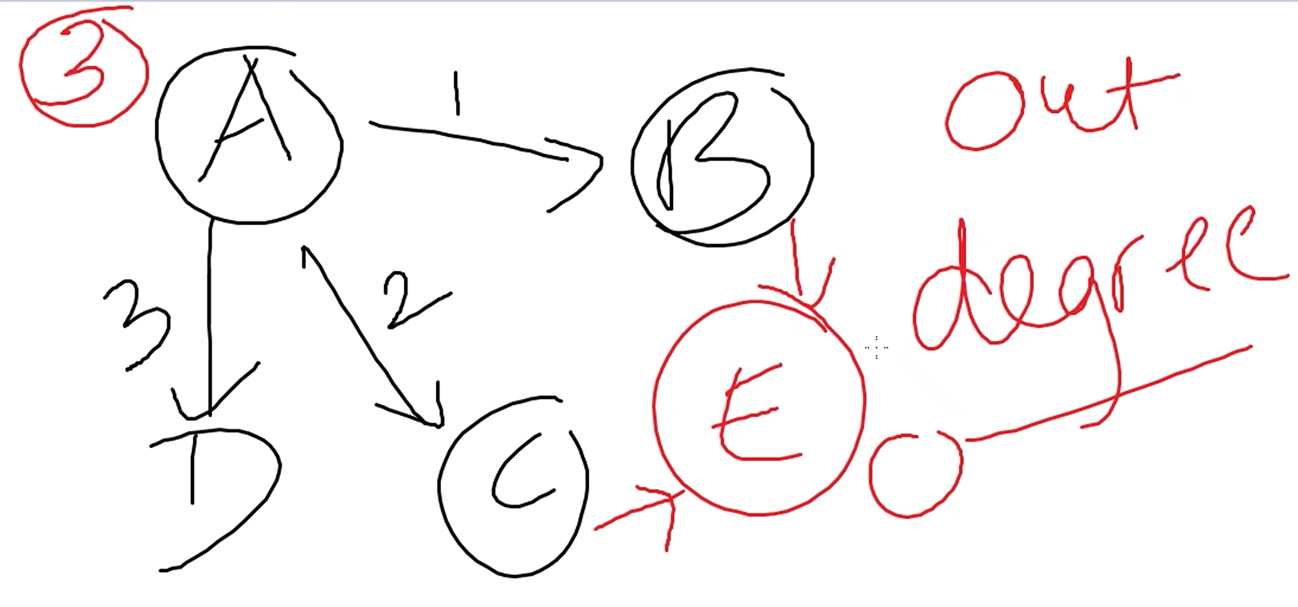
    - A has 3 degrees, E has 0, B and C have 1
  + 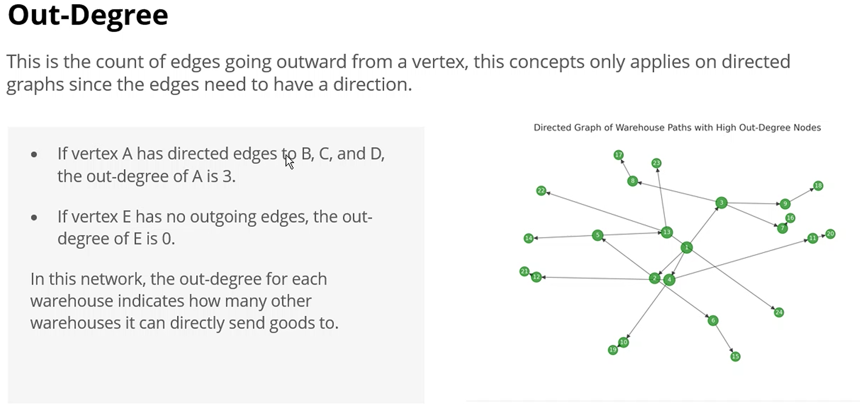
* *In Degree*—Count of edges going inward toward a vertex; only applies to direct graphs
  + 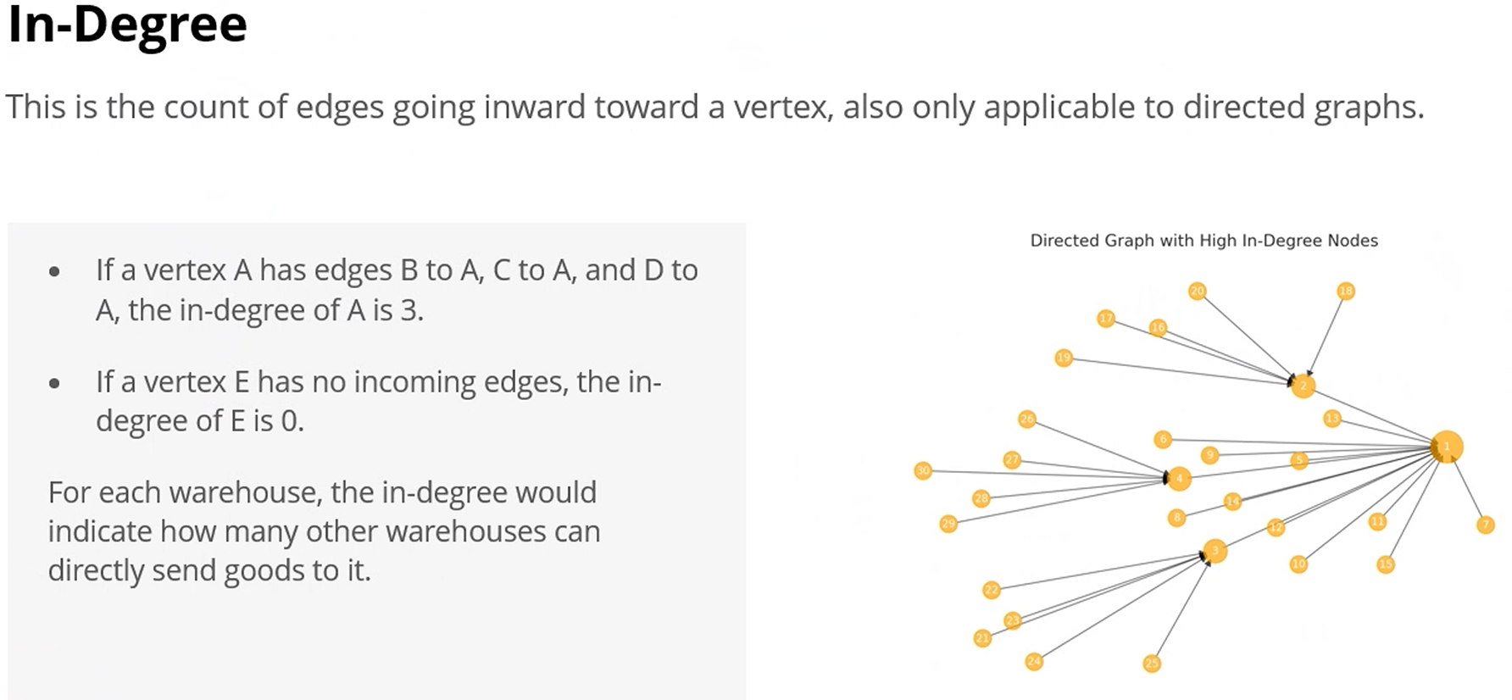
  + Whiteboard example above: A has 0, E has 2, B/C/D have 1
* Types of Graphs
  + *adjacencyList*—Stores the relationships in the graph. It has an index and a list as an entry, representing each vertex and its edges as a list. Makes it a dynamic collection.
    - Can basically add a list to a dictionary as the values for the keys
      * Dictionary<int, List<(int destination, int weight)>>
  + *AddVertex*—ensures that each vertex exists in the dictionary
  + *AddEdge*—adds an edge by adding each vertex to the other’s adjacency list
  + *DisplayGraph*()—method prints each vertex and its neighbors
  + Undirected Graph: two-way
    - Use a generic dictionary <key, list>
      * 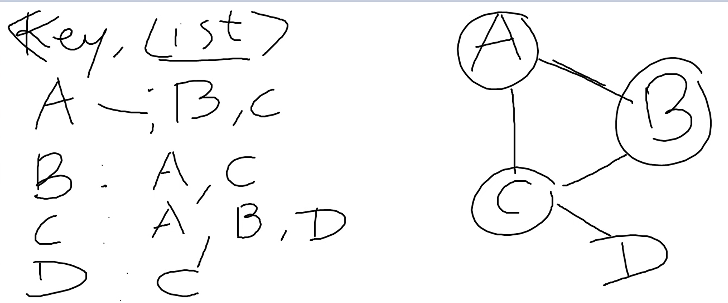
        + Key—will be Vertex (node)

A-;B, C

B-A, C

C-A, B, D

D-C

* + - * + List—Who the vertex is connected to
  + Directed Graph: one-way
  + 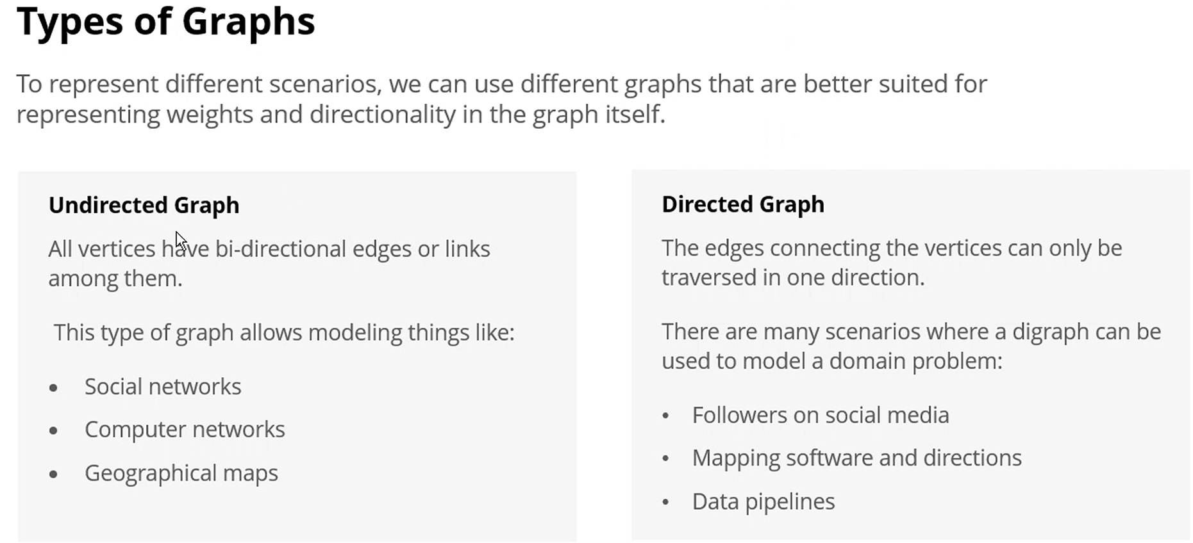
  + *Weighted Graph*—always a directed graph
    - 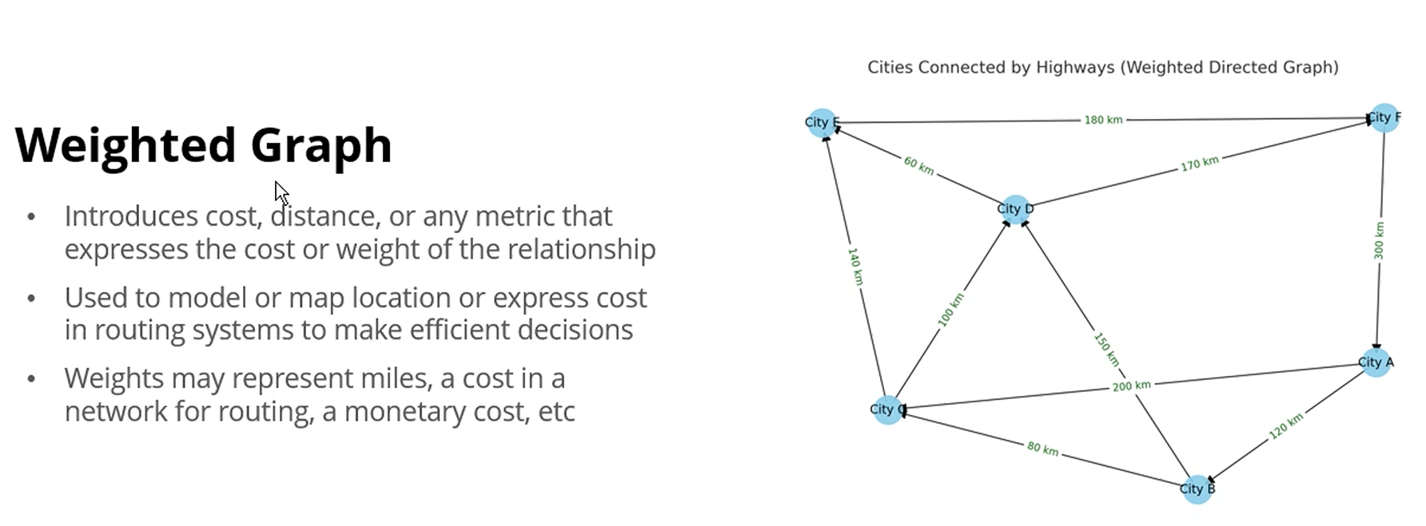
    - 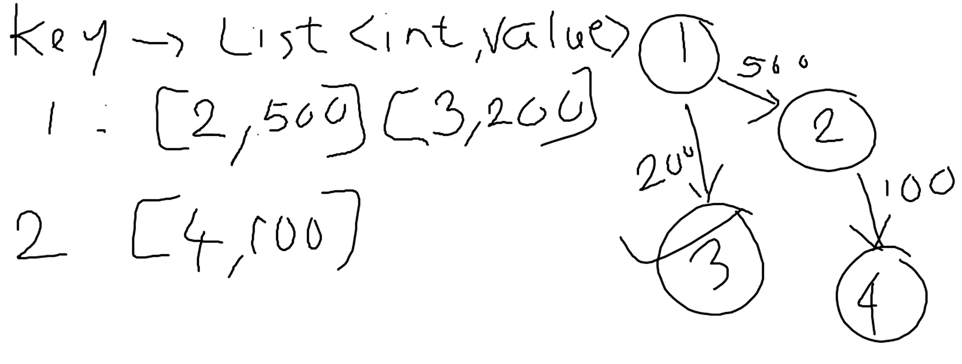
  + *Adjacency List and Adjacency Matrix—*
    - 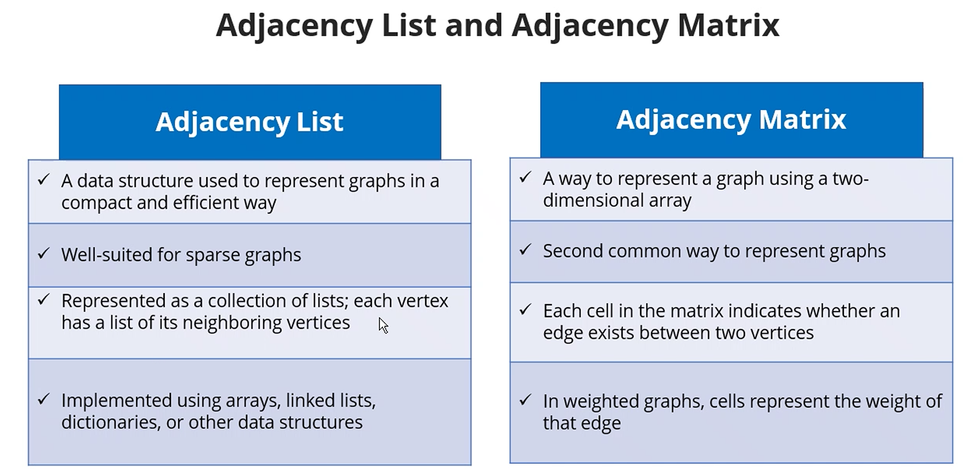
    - *List*—0h55m 3 March 25
    - *Matrix*—2D array. Good for fixed-size graph, not worried about space
      * A different value other than 1 represents a connection and a weight
      * 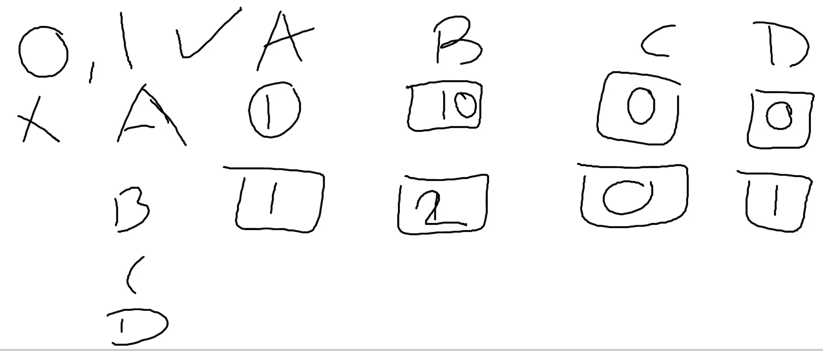
        + A is connected to B, 1
        + A is not connected to C, 0
        + A is not connected to D, 0
        + B is connected to A, 1
        + B is connected to B (same), 1
        + B is not connected to C, 0…

**Breadth-First Search (BFS)**

* Explores connections layer by layer, moving outward from a starting point
* Checks all direct friends, friends of friends, friends of friends of friends, and so on…
* 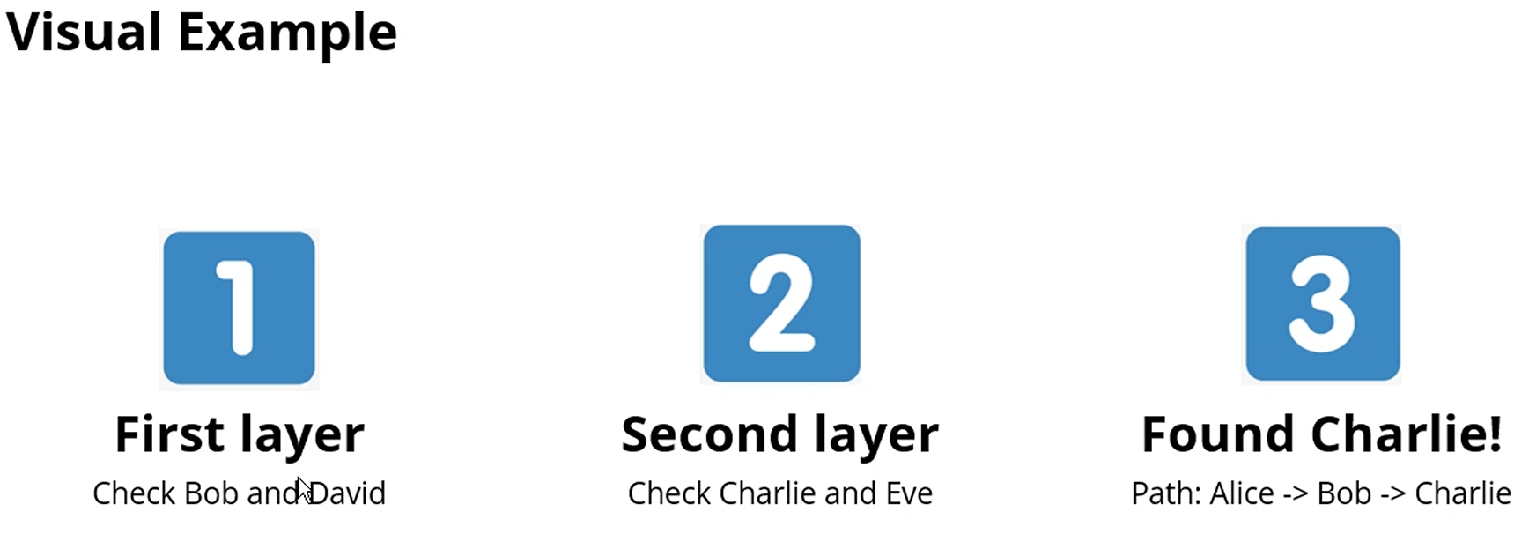
* 1) Subdivide the vertices into levels
* 2) Start at a vertex (considered level 0)
* 3) Identify all the vertices reachable from start vertex in level 1
* 4) Mark all visited nodes as visited
* 5) Identify all the vertices which are reachable in level 2
* 6) Process will continue until no further vertices are found
* 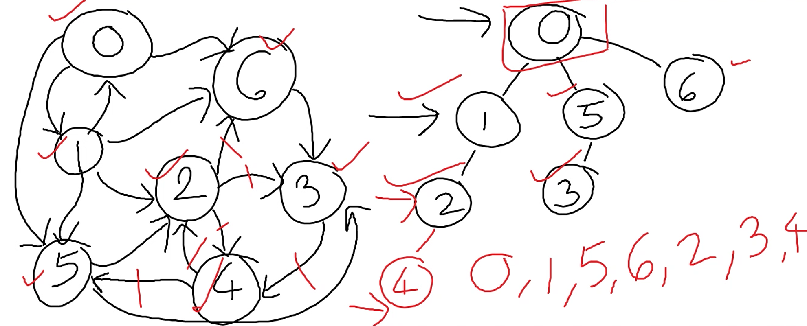
  + Output: 0,1,5,6,2,3,4

**Depth-First Search (DFS)**

* 1) Start at a vertex
* 2) Select the adjacent vertex from the start point
* 3) Visit the adjacent vertex, mark as visited
* 4) Continue the above steps until there are no more unexplored edges and backtrack to previous node
* 5) Recursive approach

**Trees and Graphs**

* Use Cases
  + 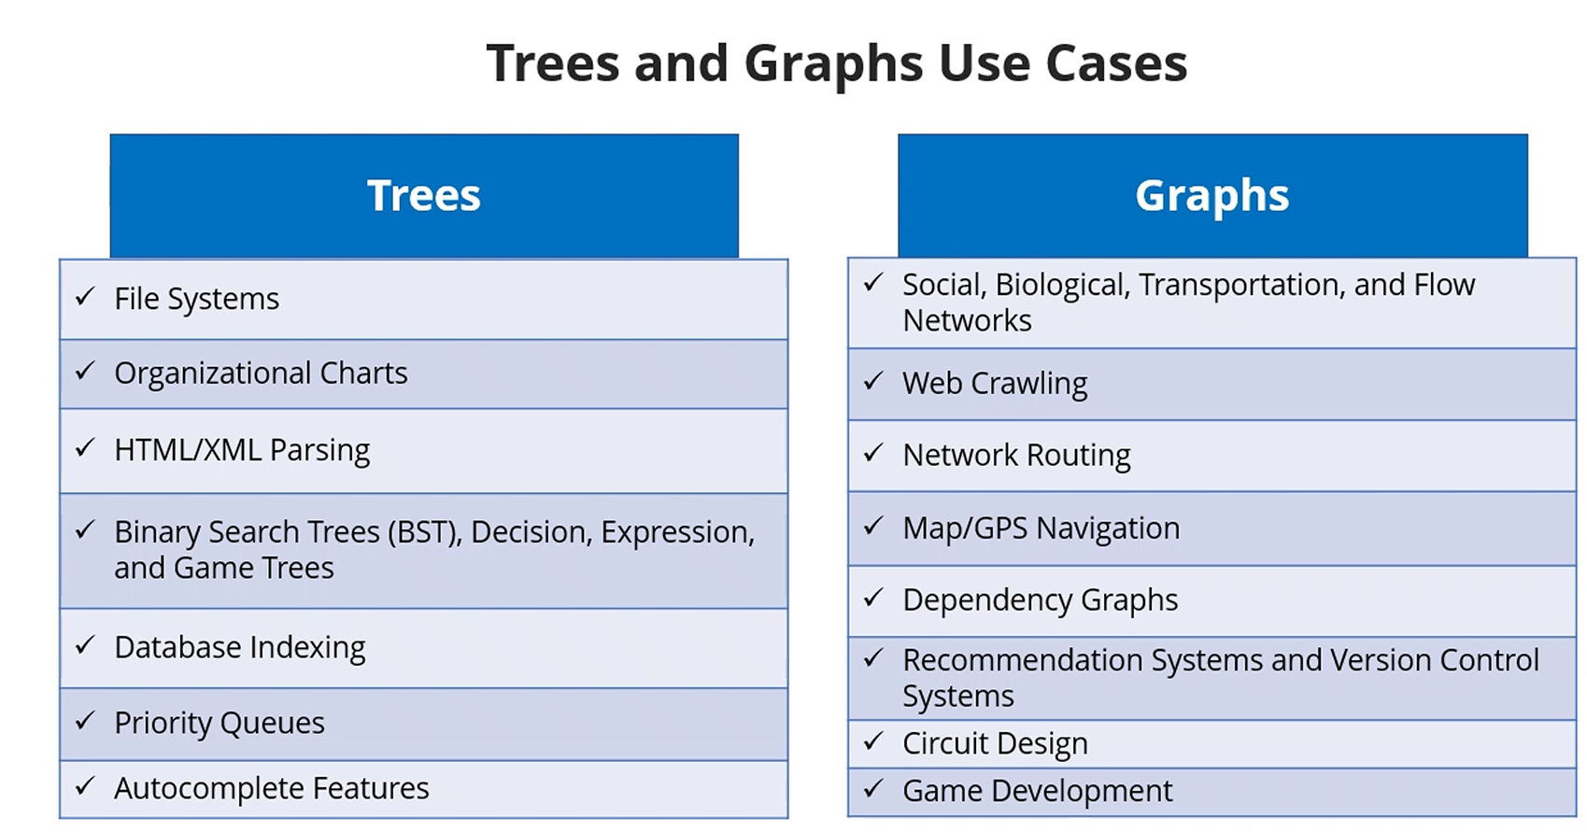

**Quick Sort**

* 1) Divide the collection into subsets/partitions
* 2) Partition index == pivot index
* 3) Recursively sort left and right side of the partition/pivot index by further finding partition/pivot index
* 4) Recursive approach until there is only 1 element in that partition
* Example:
  + 54 78 92 45 86 15 28 37
  + i : pointing to first element (54)
    - I want to place 54 in its correct spot
  + j : beyond the array/one more than the array (array.Length +1)
    - 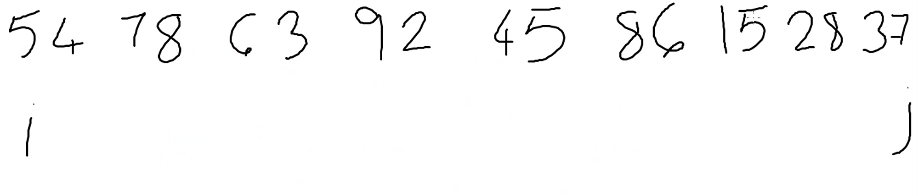
  + i increments, j decrement
    - 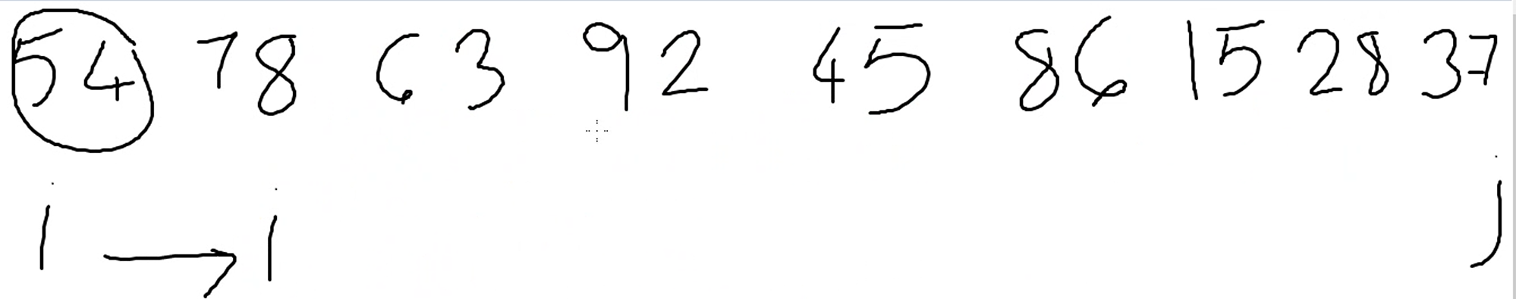
  + compare the element at ith position with pivot (54)
    - if the number is more (i > pivot), stop i
      * 78 > 54, i stops
    - if lesser (i < pivot), more i right by 1 position
  + Compare jth element with pivot
    - If number is smaller (j < pivot), stop j
    - If number is larger (j > pivot), move j left by 1 position
  + When I and j stop, swap elements at I and j
  + 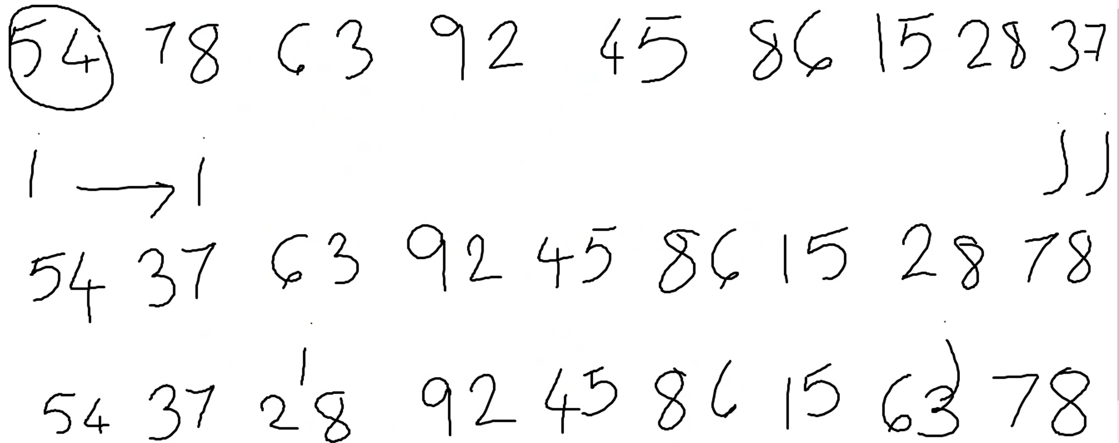
  + 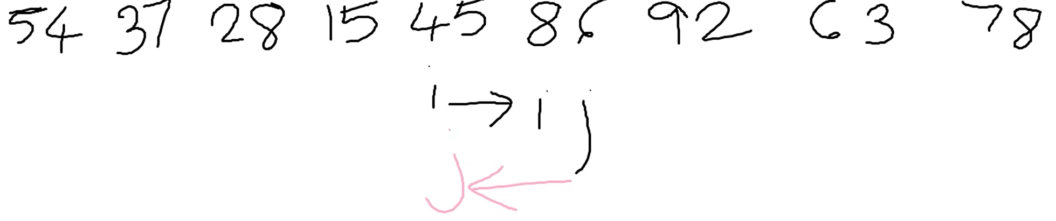
    - When J crosses I; all numbers have been scanned at this point and we have found the pivot position
      * Swap pivot (54) with element at j (45)
      * 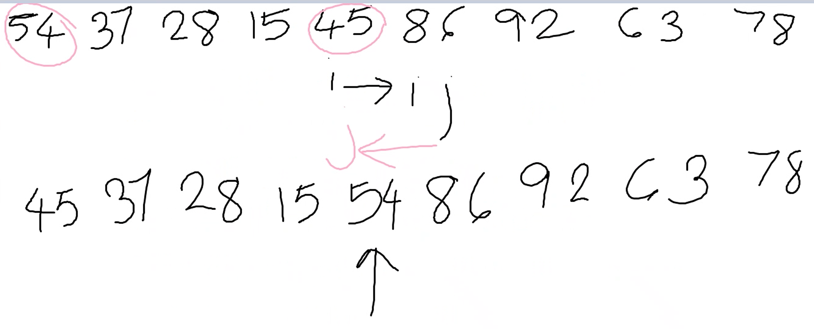
  + Left partition is now 45 – 54
    - I is now 45, j is now 54 (pivot)
    - Compare I with j
    - 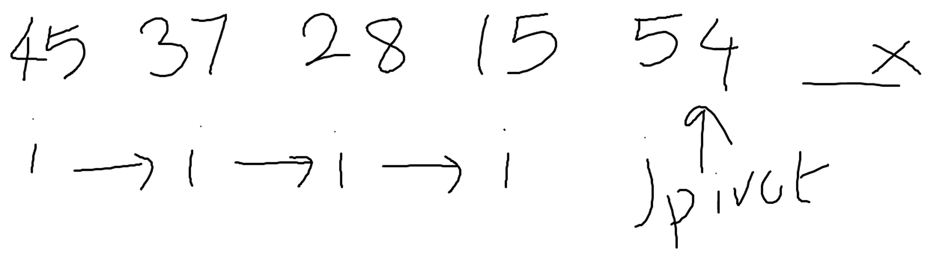
      * J moves left, j overlapped I, compare 15 and 45, swap